**Review of Literature**

**Historical background**

*Cryptosporidium* species are apicomplexan parasites. The first species described was *Cryptosporidium muris,* from the gastric glands of laboratory mice ***(Tyzzer, 1907)****.*

Light microscopical studies showed the endogenous stages of *Cryptosporidium* species(spp.) ***(Jevis et al., 1966).***

The first reports indicating that *C.parvum* as a common cause of acute diarrhea in adults were by ***Current et al. (1983***) and in children by ***Tzipori et al. (1986)****.*

At the beginning of the 90s, a massive waterborne outbreak of cryptosporidiosis in Milwaukee (Wisconsin, USA) triggered concerns about *Cryptosporidium* as a significant waterborne pathogen ***(MacKenzie et al., 1994)*.**

*Cryptosporidium* is derived from the Greek word "Kryptos" meaning hidden and "spores" meaning seed being difficult to be detected ***(Youssef, 1995).***

From 1983 onward *C. parvum* emerged with AIDS as a life-threatening disease. In 1993 *C. parvum* reached the public domain when it became widely recognized as the most serious cause of water-borne related diarrhea ***(Tzipori* and Griffiths *1998)****.*

Following the initial discovery of *Cryptosporidium,* the parasite was commonly confused with other apicomplexa genera, especially members of the coccidian genus *Sarcocystis* because many *Sarcocystis* species have oocysts with thin walls that often rupture releasing free sporocysts, moreover each sporocyst contains four sporozoites like *Cryptosporidium* oocysts ***(Morgan et al.,2002)***.

Cryptosporidiosis was first recognized in human in 1976 and came to prominence in 1980 and 1990 as a cause of severe diarrhea in patients with acquired immune deficiency syndrome (AIDS) ***(Lima et al., 2002).***

***Moore et al. (2002)*** reported that from April 2000 to April 2001, three separate cryptosporidiosis outbreaks affected more than 475 people in the greater Belfast area of Ireland, these outbreaks were due to contaminated sewage water that entered the water distribution system.

*Cryptosporidium* was first recognized as a potential cause of diarrhea in turkeys in 1955 ***(******Tzipori and Widmer, 2008)*.**

**Taxonomy**

Molecular characterizations of *Cryptosporidium* have helped to clarify the confusion in *Cryptosporidium* taxonomy and validate the existence of multiple species in each vertebrate, as a result several new species of *Cryptosporidium* have also been named ***(Gatei et al.,2003)***.

Currently, 26 *Cryptosporidium* species that infect mammals, birds and human were morphologically, biologically and molecularlly confirmed ***(Adamu et al., 2014)***. *C. parvum* and *C. hominis* are usually the most common species in human*.*

*C. parvum* is responsible for slightly more infection than *C. hominis* ***(Xiao, 2010)****.* There are at least 16 established *Cryptosporidium* species and more than 40 unnamed genotypes at least 8 of them have been reported in humans as *C. hominis, C.parvum, C.meleagridis, C. felis, C. canis, C. muris, C. suis*, and *C. cervine* genotype***(Robinson et al., 2008)***. Molecular characterization of the 60-kDa glycoprotein (GP60) gene of *C. hominis* and *C. parvum* has enabled further division into subtypes ***(Xiao, 2010)****.*

Based on classification system proposed by [***Levine (1985)***](http://scialert.net/fulltext/?doi=aje.2015.48.63&org=11#52705_bc)

|  |  |
| --- | --- |
| **Pylum** | Apicomplexa |
| **Class** | Sorozoasida |
| **Subslass** | Coccidiasina |
| **Order** | Eucoccidiasina |
| **Suborder** | Eimeriorina |
| **Family** | Cryptosporidiiae |

***\*Cryptosporidium* species**

**Table (1): *Cryptosporidium* species*****(fayer et al., 2000).***

|  |  |
| --- | --- |
| *Cryptosporidium* species | Initially described host species |
| *C.andersoni* | Bas taurus (cattle) |
| *C.baileyi* | Gallus gallus (domestic chicken) |
| *C.felis* | Felis catis (domestic cat) |
| *C.meleagridis* | Meleagris gallopavo (turkey) |
| *C.muris* | Mus musculus (house mouse) |
| *C.nasorum* | Naso literatus (fish) |
| *C.parvum* | Mus musculus (house mouse) |
| *C.saurophilum* | Eumeces schneideri (skink) |
| *C.serpentis* | Elaphe guttata (corn snake)  E.subocularis (rat snake)  Sanzinia madagasarensus (Madagascar boa) |
| *C.wrairi* | Cavia porcellus (guinea pig) |
| *C.homonis* | Humans |

**Morphology**

**A) Light microscopy (L.M.):**

Examination by L.M using Modified Zeihl Nelseen stain (MZN) with 100 magnification power by oil immersion lens shows the following different developmental stages:

1. **Trophozoite**: It is the youngest developmental stage of the parasite about 3.1 x 3.2 um in size, spherical in shape containing an eccentrically located nucleus within the cytoplasm ***(Current and Reese., 1986)****.*
2. **Schizonts (Meronts):** Type I meront with six to eight merozoites is 4.3x 4.8 um in size and it is banana-shaped with a slight curvature. A spherical to subspherical nucleus is located in the central third of the parasite ***(Current and Reese, 1986)****.*

Type II meront is 3.4 x 3.6 um in size and it is banana shaped, blunt ends and slightly curved with a spherical nucleus near the center of the cell ***(Current, 1985)****.*

1. **Mature Merozoites**: Type I merozoites are released from type I meronts and they are banana-shaped with a slight curvature. A spherical nucleus is located in the central third of the parasite. Type I merozoites displayed gliding and flexing movements which resulted in attachment of parasites to the microvillous border of host cells ***(Marcial and Madara, 1986)****.*

Type II merozoites are banana-shaped, blunt ends slightly curved with a spherical nucleus near the center of the cell. They are released by rupture of the parasitophorous vacuole displaying flexing and gliding movements and are frequently observed penetrating into microvillous border of enterocytes ***(Current and Reese, 1986)****.*

1. **Microgamete**: Microgamete is about 3.9 x 3.8 um in size. Immature microgamete contains two to 16 compact peripheral nuclei. While mature microgamete is bullet shaped, non-flagellated, having a slightly expanded anterior end and a nucleus that occupies most of the center of the cell ***(Brandler, 1982)****.*
2. **Macrogamete**: Macrogamete is about 4 um in size and its cytoplasm is vacuolated and has defined loops of rough endoplasmic reticulum ***(Navin and Juranek, 1984)****.*
3. **Oocysts**: There are two types of oocysts, the thick and the thin-walled oocysts (about 5 x 4.8 um in size) sporulate within the parasitophorous vacuole and are released from the host enterocytes passing unaltered through the gut. However, several thick walled occysts are observed releasing sporozoites. Thin-walled oocysts have a very thin wall (membrane) surrounding four sporozoites **(Fig. 1) *(McDonald and Kelly, 2005)****.* The previous description of different stages cannot be done except by special technique of light microscopy to get about x 2200 magnification ***(Canning, 1990).***

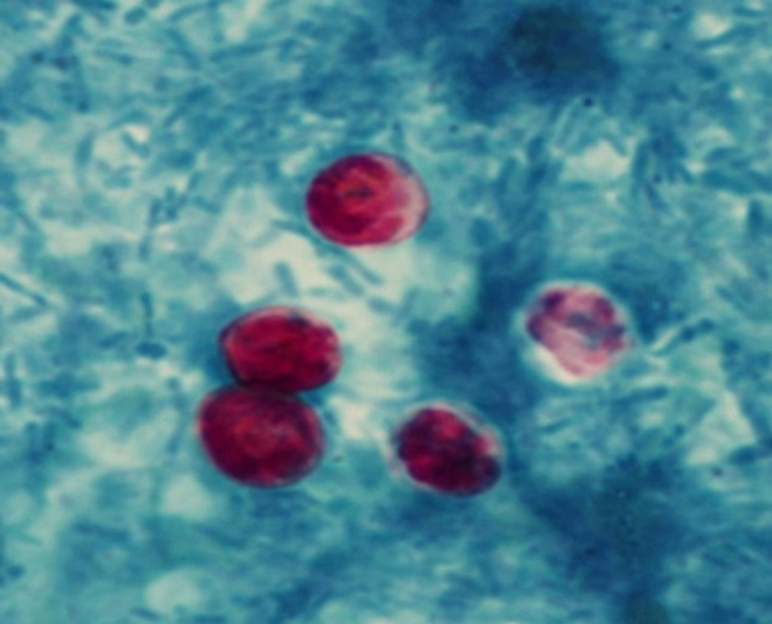

**Fig. (1):** *Cryptosporidium* oocyst with MZN stain (× 1000). Quated from [www.dpdx.cdc.gov.](http://www.dpdx.cdc.gov.)

**B) Electron microscopy:**

Scanning electron microscopy was used in some cases to detect the changes of the affected mucosa in the presence of the parasite ***(Bird and Smith, 1980).*** While transmission electron microscopy is used to detect the internal structure of the organism ***(Marcial and Madara, 1986***) **(Fig. 2-4)**.

By electron microscopy, the different stages of *Cryptosporidium* are illustrated as follows**:**

**1-Trophozoite:** Trophozoites were first described by ***Vetterling et al. (1971)*** in guinea pig and by ***Nime et al. (1976)*** in human. They described the parasite as round or spherical body with a single nucleus and a large nucleolus and a rough endoplasmic reticulum with absent mitochondria. ***Goebel and Braendler (1982)*** reported that the cytoplasm of the trophozoite is surrounded by four distinct membranes. The origin of these membranes is controversial, as it is believed that the outer two membranes to be of host origin and the inner two of the parasite pellicle. Thus, the location of the trophozoite is intracellular but extra cytoplasmic. ***Marcial and Madara (1986)*** described a pentalaminar membrane surrounding the early trophozoite.

**2-Schizonts** (Meronts): ***Bird and Smith (1980)*** reported that the trophozoite nucleus undergoes two or three divisions depending on whether it will result in formation of type I (first generation) schizont containing six to eight merozoites or type II (second generation) schizont containing four merozoites.

Later on, ***Current and Reese (1986)*** described type I meront, about 4.8 um x 4.3 um in size, while type II meront about 3.9 x 3.6 um in size. They added that both types of schizonts produce merozoites by external budding which were six or eight in type I and four in type II.

**3-Mature Merozoite**: Type I merozoites are vermiform measuring about 5.2 x 1 um, while type II merozoites are shorter measuring about 4.6 x 1.2 um ***(Bird and Smith, 1980)****.*

**4-Microgametes:** They are Bullet-shaped non-flagellated microgametes have a slightly expanded anterior end and a nucleus in the center of the cell. They are about 1.1 x 0.2 um size ***(Current and Reese, 1986)****.*

**5-Macrogamete**: It had a vacuolated cytoplasm and different from schizonts by the presence of peripherally arranged electron-dense polysaccharide and electron-lucent phospholipids granules. These granules were thought to be precursors of a thick-walled oocyst ***(Bird and Smith, 1980)****.*

***Current and Reese (1986)*** reported that the mature macrogametocyte measured about 5.2 um x 5.1 um, the refractile granules and globules remained scattered in the cytoplasm and numerous small dark granules were concentrated at the periphery.

**6-Oocyst**: With electron microscopy, oocysts appear ovoid in shape with a smooth and colorless wall. A faint, longitudinal suture extends from one pole of the oocysts down each side to about 1/3 to 1/2 of the oocyst length ***(O'Donoghue, 1995)***. A large spherical or ovoid membrane bound globule is present within the oocyst about 3.4 x 3.3 um. It is usually surrounded by small residual granules. The sporozoites lie lengthwise and parallel along one side of the oocysts and external around the globule. The anterior ends of all four sporozoites lie adjacent to the oocysts pole that possesses the suture while the posterior ends of the sporozoites are reflected and extend along the opposite side of the oocyst to about 1/2 of the oocyst length ***(Upton and Current, 1985)****.*

***O'Donoghue (1995)*** reported that the oocyst wall consisted of two layers limited by three-unit membranes. The outer cyst wall was variable in thickness (190-600 nm), the inner cyst wall was limited on either side by a unit membrane, and it ranged in thickness from 210 to 215 nm*.*

***Current and Reese (1986)*** reported that the cytoplasm of the oocyst contained a single nucleus, numerous amylopectin granules, lipid bodies, and aggregates of ribosomes.

**7-Sporozoite:** ***Current and Reese (1986)*** reported that living sporozoites were comma-shaped with a rounded posterior end that tapered to a point anterior end. The compact nucleus was located in the posterior third of the parasite.

1. **(B)**

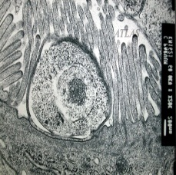 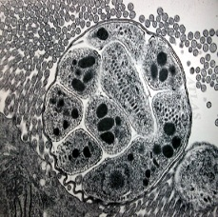

**Fig. (2):** *Cryptosporidium* trophozoite stage and type I meront located on the surface of intestinal epithelial cell. (A) Trophozoite stage (B)Type I meront (including 8 merozoites). ***(Elliott and Clarck 2000)****.*

[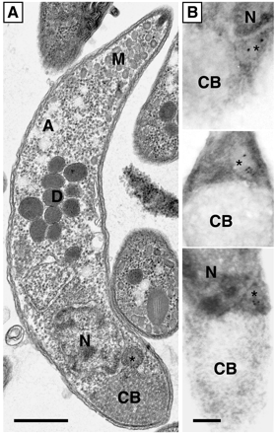](http://ec.asm.org/content/3/2/483/F7.large.jpg)

**Fig. (3):** Transmission electron microscopy of *Cryptosporidium* sporozoites (A) Longitudinal section of the sporozoite- (N) Nucleus - (CB) Crystalloid Body- (M) Micronemes - (D) Dense granules. ***(Slapeta and Keithly,2004)****.*

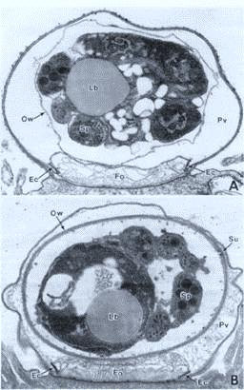

**Fig. (4):** Transmission electron microscopy of *Cryptosporidium* oocysts. A. Thin-walled oocyst and B. Thick-walled oocyst: (Ow) outer wall- (Lb)- lipid body-(Sp)- sporozoite- (Ec)- electron dense collar-(Fo) feeder organelle- (Pv) parasitophorous vacuole- (Su) suture. Quated from <http://www.ksu.edu/parasitology/basicbio>

**Epidemiology**

### Prevalence

Cryptosporidiosis has a worldwide distribution with the prevalence of infection is higher in developing countries ***(Putignani and Menichella, 2010)****.*

Cryptosporidiosis is common in sub-Saharan Africa and south Asia ***(Liu et al., 2012)***. Globally, one in ten child deaths result from diarrheal diseases during the ﬁrst 5 years of life is due to *Cryptosporidium* infection ***(Kotloff et al., 2013)***.

*Cryptosporidium* infection is prevalent worldwide, reports revealed that the infection rates varying from 22 to 26% in immunocompetent patients with diarrhea in developed countries versus 40.9% in developing countries ***(Chalmers et al., 2010)****.*

Cryptosporidium was first identified as a cause of gastrointestinal disease in human in 1976 and is now recognized as an important cause of diarrhea in both children and adults ***(Yoder et al., 2012)****.* In a study of 9500 children in Africa and Asia seeking care for diarrhea, Cryptosporidium was found to be the second most common pathogen during infancy and among children without HIV***(Kotloff et al., 2013)****.*

Cryptosporidium spp. mainly C. hominis and C. parvum, have been responsible for large-scale waterborne epidemics in the developed world ***(***[***Sow et al., 2016***](http://www.sciencedirect.com/science/article/pii/S2213224416300542#bib34)***)****.*

Warm temperature is one of the most critical parameters to increase the prevalence of cryptosporidiosis. Temperature can be one of the most important triggers of excystation ***(Cacciò and Putignani, 2014)***. C. parvum is associated with rural areas and animal contact ***(Chalmers et al., 2011).***

Studies in developing countries indentiﬁed several risk factors: age <2 years, absence of breast feeding, contact with pets, living in overcrowded conditions, lack of clean water and sanitary facilities, low birth weight, male gender, malnourishment and co-infection as signiﬁcant risk factors for cryptosporidiosis ***(Putignani and Menichella, 2010)****.*In Benha city in Qauliobyia governorate, ***Khashab et al. (1989)*** stated that prevalence of *Cryptosporidium* among diarrheic children was 3.2%. ***Abd El-Maboud (1996)*** reported that *Cryptosporidium* infection rate was 5.6% among 250 cases of all ages in Benha city. ***El-Ghareeb (1999)*** reported that the percentage was 12% among 320 children in Qauliobyia governorate*.* ***Mostafa, (2000)*** revealed that infection rate was 13.8% among 1087 cases of all ages in Benha city. ***Abdel Messih et al. (2005)*** reported the prevalence of *Cryptosporidium* was more than 17% in 1275 children below 5 years of age, study sites included Benha Fever Hospital and Abu Homos District Hospital (southeast of Alexandria).

The prevalence of *Cryptosporidium* in children in Ismailia province was estimated as 33.3% ***(Shoukry et al., 2009)****.* The prevalence of *Cryptosporidium* was 31.1% in out- and in- patients from different areas in Cairo province ***(Mousa et al., 2010)****.*

In Egypt ***Al-Hindi et al. (2007)*** performed a study to determine the prevalence of cryptosporidiosis among children in Gaza, Palestine and found that *Cryptosporidium* prevalence was 14.9% by using acid-fast stain.

***Iqbal et al. (2011)*** performed a study in Kuwaiti on faecal specimens from 2548 children with diarrhea and screened by microscopy and found the prevalence was 3.4 % by microscopy.

***El-Helaly et al. (2012)*** performed a study on 177 children in the age group from 1 to 5 years old suffering from diarrhea selected from the gastroenterology outpatient clinic, children Hospital, Cairo University and found that 20 cases (11.3%) were *Cryptosporidium* positive using MZN stain. ***Helmy et al. (2013)*** performed a study on 165 diarrheic stool samples from children less than 10 years and found that *Cryptosporidium*prevalence was 49.1%, of which 60.5% were *C. hominis*, 38.2% *C. parvum* and 1.2% mixed infection with both genotypes.

In Africa, cryptosporidiosis was reported in malnourished children in Nigeria with a percentage of 4.8% ***(Egah et al., 2003).*** Cryptosporidiosis is endemic in Ethiopia, prevalence rates of 7.6% to 43.6% were reported in patients with AIDS (***Alemu et al., 2011).*** In Kenya the prevalence rate was 4% ***(Hart et al., 2006)****.*

C. hominis is more prevalent in North and South America, Australia, and Africa, while C. parvum is common in Europe, especially in the UK ***(Aldeyarbi et al.,***[***2016***](http://link.springer.com/article/10.1007%2Fs00436-017-5376-3#CR6)***)****.*

Cryptosporidium parasites are found in every region of the United States and throughout the world. In the United States, 748,000 cases of cryptosporidiosis occur each year ***(Scallan et al., 2011)****.* Large outbreaks are due to contamination of water supplies. Drinking contaminated water is a major risk factor for cryptosporidiosis in the USA ***(Tzipori and Widmer, 2008)****.*

In the United States, a seasonal peak was observed in the Autumn season (reacreational water and swimming pool), with 59% of cases reported between August and November. However, in Ireland and Spain has a peak in Spring (calves and farmes) and Summer, respectively. Routine cryptosporidiosis surveillance in northwest England revealed that *Cryptosporidium* infection more in Spring and Autumn ***(Chalmers et al., 2011).***

In August 2012, there was a large increase in *Cryptosporidium* infection occurred in the Netherlands, Germany, England and Scotland. In the Netherlands, 524 *Cryptosporidium* positive fecal samples for weeks 31-42 of that year, compared with 115 in 2010 ***(Fournet et al., 2012).***

***Budu-Amoako et al. (2012)*** reported that *Cryptosporidium* prevalence in Canada was 22%. In United States the annual prevalence of infection varies between 5% to 6% ***(Amin, 2002)****.*

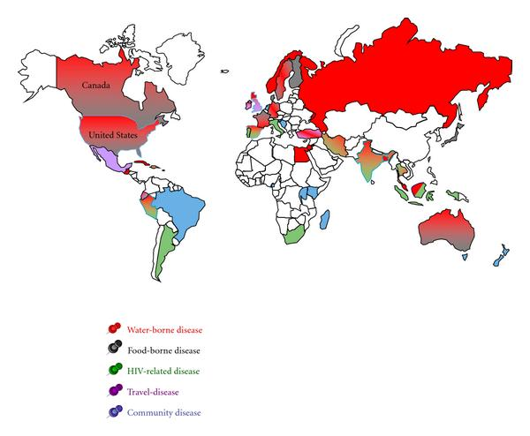

**Fig.(5):** Geography of worldwide occurrence of human cryptosporidiosis outbreaks and sporadic cases ***(Putignani and Menchella, 2010)***

**Life Cycle**

The life cycle of *Cryptosporidium* is more complex and has a homoxenous life cycle that completely developed inside a single hostand has two stages which are asexual and sexual stages ***(Tzipori and Griffiths, 1998)****.* The infection begins with the ingestion of oocysts through contaminated water or food, or by faecal-oral contact. Inhalation of oocyst is also reported as a possible way ***(Meinhart et al., 1996)***.

*Cryptosporidium* is an obligatory intracellular parasite that infects the epithelial lining of luminal surfaces of gastrointestinal and respiratory tracts in a wide variety of hosts ***(Mc Donald and Kelly, 2005)***. In immunocompetent individuals, the organism is primarily localized in the distal part of small intestine and proximal colon, whereas in immunocompromised hosts, the parasite had been identified throughout the gut, biliary and respiratory tracts ***(Mumtazet al., 2010)****.*

After ingestion of oocyst, excystation of this oocyst is induced by host and parasite specific factors as temperature elevation (37°C), gastric acidity and the presence of enzymes as proteases. This event occurs in the small intestine where favored by the presence of the neutral pH, bile salts and fatty acids, resulting in parasite-specific intracellular responses that initiate excystation ***(Smith et al., 2004)****.*

Following excystation, gliding motility, orientation, attachment and invasion that enable extracellular sporozoites to become internalized, and the content of sporozoite organelles can participate in attachment, invasion and parasitophorus vacuole formation. The sporozoites attach to the gut epithelium by orientating the anterior pole towards the luminal surface of enterocyte mediated by ligand receptor interactions ***(Tzipori and Griffiths 1998)****.*

Sporozoites become enveloped by the apical membrane of the enterocyte, which extend over the apical end of the parasite. The plasma membrane of the sporozoite fuses toward its base with the invaginated enterocyte membrane delineating a unique parasitophorus vacuole which is intracellular yet extra cytoplasmic ***(Huang et al., 2004)****.*

Parasite antigens are expressed on the parasitophorus vacuole and on part of the outer host cell membrane surrounding the parasite at the site of attachment ***(Smith et al., 2004)****.* Interaction between the parasite and host cell components resulting in the formation of the so-called feeder organelle, which expands as the parasite grows and acts as a barrier between the host and parasite cytoplasm ***(Mc Donald and Kelly, 2005)****.*

Each oocyst contains four sporozoites that are released and try immediately to infect epithelial cells of the gastrointestinal tract. The parasite then differentiates into a trophozoite that undergoes asexual multiplication by multiple fission, a process known as schizogony or merogony according to the process. The trophozoites develop into Type 1 meronts that contain 8 daughter cells (***Current, 2000)***. These daughter cells are Type 1 merozoites which can cause autoinfection by attaching to epithelial cells or evolve to Type II meronts which contain 4 Type II merozoites ***(Chen et al., 2002)****.*

Sexual cycle initiates at this point by the release of merozoites that attach to epithelial cells and become either macrogamonts (female) and microgamonts (male). This sexual multiplication is known as gametogony (***Current, 2000)****.*

The sexual cycle becomes complete upon the fertilization of the macrogametes by the microgametes released from the microgamonts and matures into a zygote, which undergoes further development into an oocyst (***Mc Donald and Kelly, 2005)****.*

This sexual cycle evolves into oocysts of two types **a)** oocysts with thin wall which represents about 20% and can reinfect the host by rupturing and releasing sporozoites that starts the process again (autoinfection process). **b)** oocysts with thick wall which represents about 80% which are excreted into the environment ***(Mc Donald and Kelly, 2005)****.*

At the end of this endogenous cycle, sporulated oocysts are formed which once shed in the environment with faeces, are ready to infect a new suitable host. The prepatent period, which means the time between the ingestion of infecting oocysts and the excretion of a new generation of oocysts, varies with the host and species of *Cryptosporidium*, but usually it ranges from 4 to 22 days. The patent period, which means the duration of oocyst excretion, ranges from 1 to 20 days ***(Mc Donald and Kelly, 2005)****.*

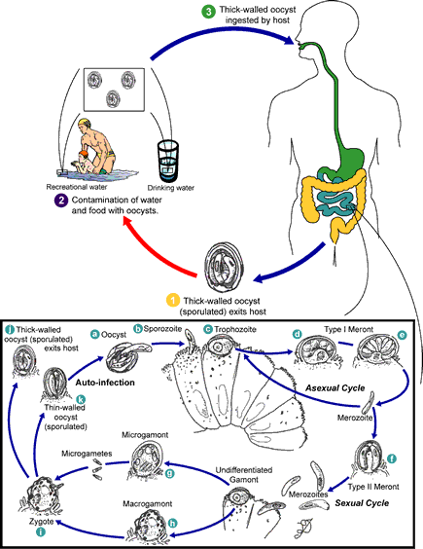

**Fig. (6):** The life cycle of *Cryptosporidium.* Quated from http://[www.cdc.gov](http://www.cdc.gov) Public health image library (PHIL) #11632.

**Modes Of Transmission of *Cryptosporidium***

Humans can be infected by *Cryptosporidium* through several transmission routes such as person to person transmission (direct contact), zoonotic transmission, foodborne transmission and waterborne transmission ***(Xiao, 2010)****.*

Oocysts are immediately infectious when excreted and are very stable and able to survive up to six months in a moist and cool environment. In water, oocysts remain viable for 140 days*.* In addition, *Cryptosporidium* oocysts are very resistant to common water disinfectants such as chlorine ***(Bouzid et al., 2013)****.*

### Person-to-person transmission (antroponotic):

In humans, the contact between person to person spreads the infection and is the cause of many outbreaks in all parts of the world ***(Mohammad et al., 2011)****.* Asymptomatic form of *Cryptosporidium* infection is common and represent a source of infection for many hosts ***(Syed and Javid, 2011)****.*

*Cryptosporidium* is easily transmitted among children and staff members in nurseries, day care centres, schools and nosocomial infections ***(Lee and Greig, 2010)****.*

**Zoonotic transmission:**

The zoonotic transmission of cryptosporidiosis comes from outbreaks involving veterinary students and researchers who had contact with infected young calves and involving children visiting farms where the same strain type was identified in animals and people ***(Hunter and Thompson, 2005)****.* Calves are frequently infected with *C. parvum* subtype that is commonly found in human in the same geographic areas ***(Xiao, 2009)****.*

Diarrheic children that had a history of contact with animals had a significantly higher *Cryptosporidium* prevalence than children with no history of contact with animals ***(Adamu et al., 2014)****.*

A study in China demonstrated that zoonotic transmission may occur between cattle and farm workers due to close contact between cattle and human ***(Ehsan et al., 2015)****.*

The role of dogs and cats in human cryptosporidiosis has been the focus of much attention. Studies in which genotyping of *Cryptospiridium* oocysts in feces of dogs and cats have demonstrated that most infection in these animals are caused by host-specific *C. canis* and *C. felis,* respectively. *C. canis* and *C. felis* are responsible for only a small number of cases ***(Lucio-Forster et al., 2010)****.*

**Waterborne cryptosporidiosis:**

Most of the data on transmission pathways for *Cryptosporidium* come from reports of outbreaks, the majority of which are waterborne ***(Karanis et al., 2007)****.*

Large outbreaks are due to contamination of water supplies. Drinking contaminated water is a major risk factor for cryptosporidiosis in the USA ***(Tzipori and Widmer, 2008)****.* Out of 71 *Cryptosporidium* described in the last decade, 40 (56.3 %) appear to be correlated to waterborne transmission ***(Chalmers, 2012)****.*

**Foodborne cryptosporidiosis:**

Contamination of different types of food with *Cryptosporidium* oocysts has been demonstrated in studies from different regions of the world. Those studies have mainly focused on fruits and vegetables because these foods are often consumed raw or after minimal thermal treatment, therefore increasing the possibility of transmission ***(Robertson and Chalmers, 2013)****.* Food handlers are source of food contamination and subsequent transmission of cryptosporidiosis ***(Robertson and Chalmers, 2013)****.*

**Respiratory Transmission:**

While *Cryptosporidium* infection of the respiratory tract has been well documented, particularly for immunocompromised individuals, disease transmission via this route has yet to be substantiated. The presence of various cryptosporidial forms lining the bronchial epithelium of lung sections suggests that the protozoan may be capable of propagating within the human respiratory tract in much the same way that it parasitizes the gastrointestinal epithelium ***(Chalmers, 2012)****.*

**Risk Factors**

**Immunological factors:**

The risk of infection is more profound in immunosuppressed persons, as measured by low CD4 T-lymphocyte counts and the severity of cryptosporidiosis increases as the CD4 T-lymphocyte cell count falls (***Houpt et al., 2005)****.* *Cryptosporidium* infection should be considered in children with acute lymphoplastic leukemia presenting with prolonged or severe watery diarrhea during chemotherapy, especially those treated with methotrexate (***Hassanein et al.,2012)****.*

**Age:**

Studies in various tropical countries have shown that children less than 2 years of age are more susceptible to *Cryptosporidium* infection due to weak immune response, with a reported incidence ranging from 1.1% to 18.9 % ***(Ajjampur et al.,*** [***2010***](http://jmm.sgmjournals.org/content/60/5/647.full)***)****.*

***Budu-amoako e al. (2012)*** reported that 57% of *Cryptosporidium* isolates were found in children between 5 and 10 years of age in Prince Edward Island (Canada) and also reported that older children may be more susceptible to *Cryptosporidium* infections, because they eat without washing their hands, play in soil and sewage water, exposed to more faecal oral contact or through contaminated food or water.

**Sex:**

It has been found that *Cryptosporidium* infection is more common among males than females due to playing of male children in gardens and farms outdoor area with soil and animals which can increase the risk of parasite transmission ***(Gatei et al., 2006)***.

***El-Helaly et al. (2012)*** reportedhigh prevalence rate of *Cryptosporidium* infection in Egyptwas detected among males (55.6%) than females (44.4%). ***Al Hindi et al. (2007)*** found that the number of infected females with *Cryptosporidium* in Gaza, Palestine was significantly higher than males.  ***Lu et al. (2008)*** reported that the boys and girls had similar detectable positive rates of *Cryptosporidium* infection.

**Residence:**

Infection with *Cryptosporidium* is more common in rural areas due to poorly developed region with bad hygiene and residing in rural areas appears to be a contributing factor to increase the risk of exposure to zoonotic infection, low socioeconomic standard and close contact with soil and animals ***(Youssef et al., 2008)***.

**Nutritional Status:**

Cryptosporidiosis is more common and more severe in malnourished children aschildren with iron-deficiency anemia had an increased and prolonged infection and it was reported that *Cryptosporidium* was a cause of persistent diarrhea in early childhood ***(Hunter and Nichols, 2002)***.

**Type of feeding:**

Breastfeeding had a trend towards protection against *Cryptosporidium* associated diarrhea as non-breast-fed children are more exposed to infection through contaminated food and bottles ***(Abdel Messih et al., 2005)*.**

***Korpe et al. (2013)*** reported that the presence of parasite-specific immunoglobulin A in breast milk was associated with protection of Bangladeshi infants from cryptosporidiosis.

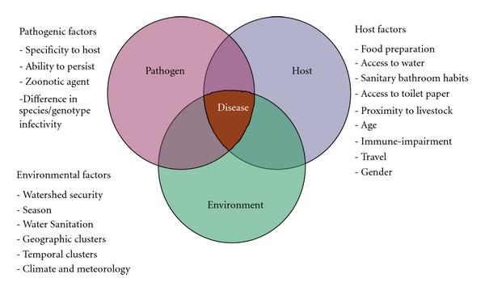

**Fig. (7):**Diagram of factors leading to *Cryptosporidium* infection. Parasite, host and environmental indexes acting as key factors for the global burden of cryptosporidiosis ***(Putignani and Menichella, 2010)***

**PATHOGENESIS**

In general, diarrhea develops when intestinal absorption is impaired, or secretion is enhanced both of these processes are regulated by the intestinal epithelial cells. *Cryptosporidium* infects the microvillous border of the intestinal epithelium and to a lesser extent the extra intestinal epithelia causing acute gastrointestinal disturbance ***(Fayer, 2004)****.*

*Cryptosporidium* resides in the apical surface of intestinal epithelial cells and elicits a strong cell mediated immune response ***(Riggs, 2002).*** The infection initiates by ingestion of the oocysts that undergo excystation releasing the sporozoites which attach to host epithelial cells by their anterior pole, followed by invagination of the host cell membrane (***Deng et al., 2004)****.*

Following the process of invagination, the surface of the sporozoites is completely surrounded forming the parasitophorus vacuole with extra-cytoplasmatic location here, it is protected from the hostile gut environment and is supplied with energy and nutrients from the host cell ***(Deng et al., 2004)***.

Attachment can be affected by several factors, such as pH and may be inhibited by the use of polyclonal and monoclonal antibodies ***(Riggs, 2002)****.* Receptor/ligand interactions between *Cryptosporidium* and the surface of host epithelial cells have been investigated, recent studies suggested that several *Cryptosporidium* proteins of sporozoites as galactose-Nacetylgalactosamine (GalNAG), specific lectin and thrombospondin-related adhesive proteins (TRAP) are involved in attachment and invasion of host epithelial cells ***(Bonnin et al., 2001)****.*

*Cryptosporidium* sporozoites do not actively penetrate the host cell membranes so, successive intermediate stages develop within the extra-cytoplasmatic space in the parasitophorous vacuole and attachment of the parasite to host plasma membrane is the primary event in the patho physiological consequences ***(Elliott et al., 2001)****.*

Rapid onset of phospholipid and protein kinase activities is observed after sporozoites attachment, also host cytoskeleton actin and binding protein (villin) are focused and aggregated in the parasitophorous vacuole ***(Chen and LaRusso, 2000)****.* By the action of the microfilaments of the parasite, the host cell cytoskeleton is modified originating a unique structure at the host-parasite interface ***(Elliott et al., 2001)****.*

Several investigators have identified impaired glucose-stimulated Na+ and H2O absorption and/or increased Cl− secretion in experimental models of cryptosporidiosis. In addition to these transport defects abnormalities in the barrier properties of the intestinal epithelium occur and contribute to *Cryptosporidium* associated diarrhea ***(Certad et al., 2007)****.*

*Cryptosporidium* also seems to induce apoptosis in host cells, also nuclear condensation and increasing apoptotic cell number was also observed in *in vitro* cell cultures ***(Chen and LaRusso, 2000)****.* The role of caspase and other apoptotic signals were investigated, and it has been suggested that *Cryptosporidium* has developed strategies to limit apoptosis to facilitate its growth and maturation in the early period after epithelial cell infection ***(McCole et al., 2000)****.*

Infection with *Cryptosporidium* is associated with the recruitment of leukocytes to the lamina propria of the mucosa and with the regulation of the expression of pro-inflammatory cytokines and several immune modulators. This suggests that intestinal epithelial cells play an important role in initiating the mucosal immune response to  infection ***(Riggs, 2002; Deng et al., 2004)****.*

Malabsorption and abnormal intestinal permeability as decreased absorption of vitamin B12, electrolytes and nutrients can be occurred. One mechanism for the induction of intestinal secretion by *Cryptosporidium* may involve the stimulation of prostaglandin production by intestinal epithelial cells ***(Chalmers and Davies, 2010)****.*

No specific toxin has been identified, although one study of young children in Haiti demonstrated the increased presence of systemic and intestinal proinflammatory cytokines (as tumor necrosis factor and interleukin 8) ***(Noel et al., 2006).*** Despite evidence for enterotoxin-like activity *in vitro* and profuse secretory diarrhea experienced by some patients, it has been hypothesized that *Cryptosporidium* produces an enterotoxin which leads to disruption and changes in the microvillous border also leads to loss of the membrane bound digestive enzymes, reduction in the absorptive surface and uptake of fluids, electrolytes and nutrient ***(Chalmers and Davies,2010)****.*

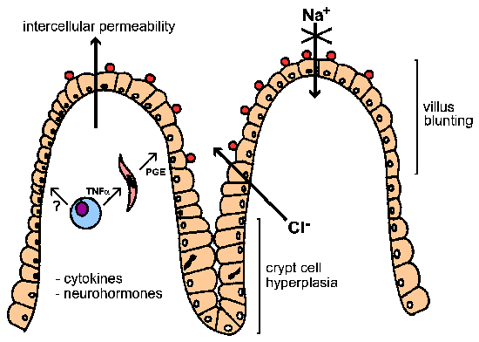

**Fig. (8)**: Schematic representation of *Cryptosporidium* pathogenesis. Many factors may be involved in the diarrhea associated with cryptosporidiosis. Quated from [www.tulane.edu](http://www.tulane.edu).

**Pathology**

The main site of *Cryptosporidium* infection is the small intestine. Although infection may be spread throughout the gastrointestinal tract from the oesophagus to the rectum, the terminal ileum was the most consistently involved ***(Chen et al., 2002)****.*

Invasion of the host cells is restricted to the luminal border of the enterocytes and leads to displacement of the microvillous border and loss of the surface epithelium causing changes in the villous architecture with villous atrophy ***(Pantenburg et al., 2008)****.*

Blunting and crypt cell hyperplasia and mixed inflammatory cell infiltration in the lamina propriacan occur and the intestine usually appears normal *but* may show mucofibrinous exudates on the mucosal surface and the intestinal mucosa appears hyperaemic ***(Chalmers and Davies, 2010)****.*

Microscopically, some infected areas may remain morphologically normal.*Cryptosporidium* appears not to infect tissue beyond the most superficial epithelia, and there is a range of histological abnormalities in crypt and villous structure including villous atrophy and crypt hyperplasia (***Carlos et al., 2002)****.*

***Trans et al. (2005)*** reported the presence of *Cryptosporidium* spp. in kidney of patients with renal transplantation and in patients with liver-transplantation ***(Gerber et al., 2000)****.*

***Poonacho and Pippin (1982)*** demonstrated that cryptosporidiosis of the liver leads primarily to mild diffuse fatty metamorphosis and bile stasis. Liver may also show mild periportal fibrosis in addition to acute and chronic non-specific portal inflammation and odema.

*Cryptosporidium* can spread via the intestinal lumen to involve the biliary system where it can cause stricture and cholangitis, also there is a case report of cryptosporidiosis affecting the esophagus in a two-years old child ***(Hunter and Nichols, 2002)****.* Lung may be affected and shows active bronchitis and focal interstitial pneumonitis characterized by the appearance of oocysts lining the bronchial epithelium and within the macrophages ***(Mor et al., 2010)****.* Distorted and dilated airspaces with hyper-distension of alveolar spaces associated with rupture of alveolar septa and severe inflammation were observed in lung infected tissues of immunocompromised mice ***(Atia et al., 2021).***

**Clinical Features**

Cryptosporidiosis presents a signiﬁcant burden on immunocompetent individuals and can have permanent effects on physical and mental development of children infected at an early age ***(Jex et al., 2011)****.*

*Cryptosporidium hominis* appears to cause more sever acute disease, more extraintestinal affection and have more recurrent manifestation after an infection than other species ***(Bushen et al., 2007)***.

1. **Gastrointestinal Diseases**

The major mechanisms have been attributed for *Cryptosporidium* diarrhea ***(Kelly et al., 1998)****.*

1-Malabsorption resulting in osmotic diarrhea.

2-Secretory diarrhea resulting from parasite enterotoxin.

3-Inflamatory products induced from parasitic infection.

**I-Immunocompetent individuals**

*Cryptosporidium* infection in immunocompetent individuals usually occurs asymptomatic, cryptosporidiosis in children under the age of five and in immunosuppressed people, results in severe diarrhea. Nausea, vomiting, discomfort and low-grade fever are other clinical symptoms which may occur during an infection with *Cryptosporidium* ***(Bouzid et al., 2013)****.*

As cryptosporidiosis is self-limited illness in immunocompetent patients, therefore only supportive management is required ***(Michael et al., 2011)****.*

After an incubation period of 5-10 days (range 2-28 days), an infected individual develops watery diarrhea with mucus*.* It is very rare to find blood or leukocytes in the diarrhea which may be associated with abdominal cramps**.** In sporadic cases, fever may be low grade or non-existent however, during outbreaks, fever may occur in 30-60% of patients ***(O'connor et al., 2011)****.*

There is often [stomach](https://en.wikipedia.org/wiki/Stomach) pain or [cramps](https://en.wikipedia.org/wiki/Cramp) and a low [fever](https://en.wikipedia.org/wiki/Fever). Other symptoms include nausea, vomiting, malabsorption and dehydration. Even after symptoms have finally subsided, an individual is still infective for some weeks ***(Harvey et al., 2009)***.

**II-Immunocompromised individuals**

Symptoms in immunocompromised patients can be very severe and even death has been described ***(Adamu et al., 2014)****.*

The clinical manifestations of cryptosporidiosis in patients with HIV vary ***(Wang et al., 2013)****.* There are 4 clinical presentations for patients with AIDS 4% have no symptoms, 29% have a transient infection, 60% have chronic diarrhea, and 8% have a severe cholera-like infection ***(Wang et al., 2013)****.* With transient infection diarrhea ends within 2 months and *Cryptosporidium* is no longer found in the feces. The most severe form results in the patients excreting at least 2 liters of watery diarrhea per day. They can lose up to 25 liters per day ***(Ryan, et al., 2004)****.* AIDS patients can have up to 10 stools per day. The volume of fluid losses through diarrhea may be extremely high, particularly in individuals with AIDS and CD4 cell counts below 50 cells/µL ***(O'connor et al., 2011)****.* When *Cryptosporidium* spreads beyond the intestine in patients with AIDS, it can reach the lungs, middle ear, pancreas, and stomach. ***(Ryan, et al., 2004)***.

**B-Pancreatitis**

Three people with AIDS presented with acute or chronic pancreatitis were related to cryptosporidiosis. All three patients had abdominal pain resistant to analgesics, increased serum amylase levels and abnormalities at both sonography and computed tomography. Endoscopic retrograde cholangiopancreatography revealed papillary stenosis in all three patients. It is difficult to assess the impact of cryptosporidiosis- related pancreatic disease ***(Hunter and Nichols, 2002)****.*

**C- Biliary Tract Diseases**

The parasite can infect the biliary tract, causing biliary cryptosporidiosis. This can result in cholecystitis and cholangitis ***(Ryan et al., 2004)****.*

Biliary tract involvement is seen in persons with AIDS who have very low CD4 cell counts and is common in children with X-linked immunodeficiency with hyper–immunoglobulin M (IgM) ***(White, 2009)****.*

Biliary involvement may include acalculous cholecystitis, sclerosing cholangitis, papillary stenosis, or pancreatitis that are associated with right upper quadrant pain, nausea, and vomiting ***(White, 2009)****.*

**D- Respiratory Tract Diseases**

Although the main symptoms of cryptosporidiosis are related to the gastrointestinal tract, in immunocompromised patients respiratory symptoms may also develop. Respiratory tract involvement is often asymptomatic, but it may manifest as bilateral pulmonary infiltrates with dyspnea. Nonspecific respiratory symptoms including shortness of breath, wheezing, cough, hoarseness, and croup may be a manifestation of respiratory infection ***(Cama et al., 2008)****.*

**Immunology**

**Immune responses to *Cryptosporidium* Infection:**

Host immunity plays a major role in limiting the consequences of primary infection and this is evident from life-threatening nature of the disease in individuals with an impaired immune system ***(Thomson & Chalmers, 2002)***.

**\*Innate Immunity**

**Natural killer cells (NK cells)**

NK cells orginate mainly in the bone marrow and migrate to other organs. NK cells may be cytotoxic against infected cells and are regarded as the major source of IFN-c in innate immunity.They are activated by cytokines, including IL-12, IFN-a/b, IL-15, TNF-a and IL-18 produced by dendritic cells and macrophages.NK cells play a part in immunity against other intracellular parasitic protozoa, including apicomplexans ***(Korbel et al., 2004)****.*

**Dendritic cells (DCs)**

The protective role of dendritic cells against cryptosporidia has not been extensively examined. However, two *in vitro* studies involving bone-marrow derived mouse dendritic cells exposed to *C. parvum* sporozoites or parasite antigen undergo apoptosis soon after invasion by sporozoites ***(Liu et al., 2009)****.*

**Myeloid cells**

Cryptosporidial infection is associated with an inflammatory response involving different myeloid cells, but few investigations have been made of the contribution of the individual cell types to immunity. However, the observation that neonatal as well as adult mice mount resistance against *C. parvum* infection suggests myeloid cells are important mediators of host resistance ***(Barakat et al., 2009)****.*

**Neutrophils**

Neutrophils contribute significantly to the intestinal inflammatory response during cryptosporidial infection but their involvement in immunity is poorly understood. In an *in vitro* study, macrophage activation induced by *C. parvum* antigen that was shown to have a protective role *in vivo* was enhanced by co-culture with neutrophils. As neutrophils and macrophage produce free radicals of nitric oxide (No) which reduce the epithelial infection and oocyst shedding ***(Takeuchi et al., 2008)****.*

**Intestinal epithelial cells (IECs)**

As the target for infection by cryptosporidia *in vivo*, epithelial cells might be expected to play a central role in innate immunity. Investigations suggest that in response to infection, the epithelium activates mechanisms that help to maintain structural integrity, establish an inflammatory response and contribute to parasite killing. One potential protective measure against parasite replication is epithelial cell apoptosis. Infection of epithelial cells alters expression of hundreds of hosts cell genes, many of them associated with apoptosis.Epithelial cellsare also a cellular source of IL-18 (IFN-Y-inducing factor) ***(Liu et al., 2009)****.*

**Toll-like receptors (TLRs)**

The mechanisms by which cellular innate inflammatory responses are initiated by *Cryptosporidium* infection are poorly understood. One possible pathway would involve TLRs expressed by immune and non-immune cells that are important inflammatory sensors of specific molecular structures of microbial pathogens. The TLRs in enterocytes play dual roles in protecting the mucosal surface by helping to maintain homeostasis and promoting inflammation following mucosal injury ***(SantaolallaandAbreu, 2012)****.* Studies with human biliary epithelial cells (cholangiocytes) infected with *C. parvum* suggest that signalling though TLRs is important in the initiation of the inflammatory response of these cells. Cholangiocyteswere found to express TLRs and significantly, infection by *C.parvum* attracted both TLR2 and TLR4 to the site of parasite development on the epithelial cell surface ***(Chen et al., 2005)****.*

**\*Adaptive Immunity**

Recent investigations on immunity to *Cryptosporidium* proved that both humoral and cellular immunity are involved in the resolution of cryptosporidiosis and resistance to infection ***(Robinson et al., 2000)***.

**1-Cell mediated immunity**

The adaptive immune response induced by specific antigens recognized by T- and B-cells is generally required to eliminate rapidly proliferating or virulent microbial pathogens and has the added advantage over innate immunity in having immunological memory, which allows prompt reactivation of memory T- and B-cells if re-infection occurs ***(Kalia et al., 2006)****.*

T-cells activate B-cells to proliferate and differentiate into plasma cells that produce antibodies. Both CD4 and CD8 T cells contribute to resistance to and clearance of acute cryptosporidial infection ***(Borad and Ward, 2011)****.* In human with late-stage HIV infection and low CD4 T-cell counts, there is increased susceptibility to cryptosporidial infection, and the severity of disease is greater. It is evident, therefore, that CD4 T-cells are major effector cells in immunity to cryptosporidial infection.The significance of CD8 T-cells in immunity is not well understood ***(Panterburg et al., 2008)****.*

**2-Humoral immunity (Antibody response)**

*Cryptosporidium*-specific antibodies appear in the circulation and in the mucosa during infection of different mammalian hosts, including human, cattle and sheep. The presence of *Cryptosporidium* specific antibodies is indicative of exposure to the parasite and is widely used to estimate seroprevalence ***(Priest et al., 2006)****.*

IgM, IgG and IgA titers measured by ELISA generally increase during infection and decline after recovery, although IgG in serum may persist for several months longer than IgM. These infection antibodies have been shown to recognize a wide range of oocyst polypeptides of low to high molecular weights. Secretory IgA produced by a host as a result of infection can play a major part in protecting the mucosal surface from toxins and microbial pathogens. In *C. parvum* infected immunocompetent human adults, the level of parasite-specific IgA was found to be higher in individuals excreting oocysts or with diarrhea ***(Dann et al., 2000)***

**DIAGNOSIS OF CRYPTOSPORIDIOSIS**

**І - Clinical diagnosis:**

The specific diagnosis of cryptosporidiosis including the precise identification and characterization of *Cryptosporidium* spp. which is important to control this disease in human and a wide range of other animals but clinically the signs and symptoms of *cryptosporidiosis* are nonspecificand vary from person to person, therefore clinical diagnosis is not suitable, however *Cryptosporidium* infection should be suspected in immunocompromised patients with persistent diarrhea ***(Caccio & Pozio, 2006)****.*

**II -Laboratory diagnosis:**

Detection of *Cryptosporidium* infection can be achieved by the following methods:

**(1) Direct microscopical stool examination:**

Parasitological examination of stool is accessible and non-invasive for the patient, but oocysts are eliminated at intermittent intervals so stool examination should be repeated three times at three-day intervals. Because of the small size of the *Cryptosporidium* oocysts, it is difficult to identify in fresh samples without specific stain ***(John & Petri, 2006)****.*

**a-Direct Wet Mounts:**

***Jokipii et a1. (1983)***recommended preliminary screening of cryptosporidiosis using direct wet mount preparations and found that this method to be insensitive and not particularly helpful, although it may be helpful for detecting cysts or ova of other parasites that may be present in stool and has the advantage of being noninvasive.

Microscopy is time consuming and requires an experienced observer to identify the organism. Furthermore, it must be performed on three stool samples to increase sensitivity leading to decreased patient compliance and delay in the final diagnosis ***(Weitzel et al.,2006)****.*

By using iodine wet mounts, the *Cryptosporidium* oocysts were shown as unstained colourless structures while yeasts and other faecal contents were stained brown**(Fig. 9) *(Weber et al., 1991)****.*

**Fig. (9)***: Cryptosporidium* oocyst stained with direct iodine wet mount (×40). Quated from. [www.dpdx.cdc.gov.](http://www.dpdx.cdc.gov.)

**b-Concentration methods:**

Oocysts may be examined under phase-contrast microscopy after concentration by different techniques. Oocysts may be concentrated by the modified zinc sulfate centrifugal flotation technique or by Sheather’s sugar flotation to maximize oocyst recovery ***(Weber et al., 1991)***. Another stool concentration technique involves formalin-ethyl acetate sedimentation followed by flotation over hypertonic sodium chloride solution to separate oocysts from stool debris. Oocysts appear as highly refractile spherical bodies (4 to 6 µm)***(Weber et al., 1991)***.

**c- Staining:**

**Modified Ziehl Nelseen stain**

Acid fast stanining techniques in *Cryptosporidium* oocyst detection include Zeihl Neelsen stain (classic, modified). Auramine-roodamine stain and auramine phenol stain are non-specific fluorescent stains that gives yellow fluorescence to the *Cryptosporidium* oocysts against dark background ***(Caccio and Widmer, 2014)****.*

Modified Ziehl Neelsen stain is the best staining technique. The oocysts appear as spherical elements and contain four sporozoites. The background is stained blue or green depending on the counterstain used (Fast Green, malachite green or aniline blue) **(Fig. 10) *(Sunnotel et al., 2006)****.* The traditional staining methods such as Modified Ziehl Neelsen stain are still the easier and cheaper traditional staining and are widely used despite their lower sensitivity ***(Caccio and Widmer, 2014)****.*

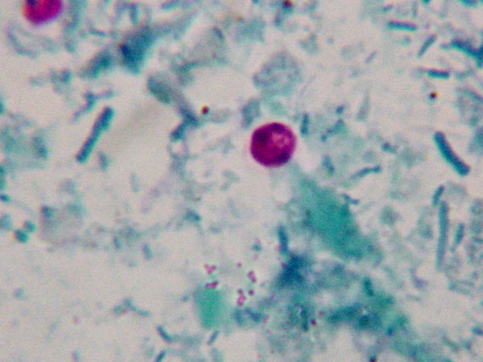

**Fig. (10)**: *Cryptosporidium* oocyst stained with MZN stain (× 1000). Quated from [www.dpdx.cdc.gov.](http://www.dpdx.cdc.gov.)

**Giemsa stain**

Romanowsky stains such as Giemsa and Jenner's stain were first to be used for the identification of the oocysts. Oocyst appears semi-translucent with a narrow clear halo around it and stains blue to azure with four to six red or purple eosinophilic granules appearing as dots ***(Smith, 2007).*** The specificity of microscopy depends on the skill of the microscopist to differentiate oocysts from other bodies in smears ***(Jex et al., 2008)****.*

**Fluorescent stain**

Auramine-rhodamine, auramine-phenol, auramine-carbol fuchsin, and acridine orange can be used in staining of *Cryptosporidium parvom*. Its main advantage is rapid screening and higher detection efficacy than microscopy and enzyme-linked immunosorbent assay (ELISA). Low sensitivity, low specificity, and high cost are its limitations ***(Vohra et al., 2012).***

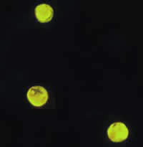

**Fig.(11): Oocysts of *Cryptosporidium parvum* stained with the fluorescent stain auramine-rhodamine (**[***Dolma***](https://www.wikidoc.org/index.php/User:Kalsang_Dolma)***, 2012).***

**(2) Electron microscopy:**

Thin sections of possible oocysts in faeces may be useful in providing definitive identification of developmental stages of the parasite ***(Petrella et al., 1991)****.* The size, shape and surface marking of *Cryptosporidium* oocysts in faeces were recognized by electron microscopy ***(Baxby et al., 1984)****.*

**(3) Histopathological Diagnosis:**

Cryptosporidiosis can be diagnosed by identifying different stages of the parasite (meronts, micro and macrogametes) in intestinal biopsy. The parasite stains lightly with hematoxylin and eosin (H &E) and appear as small round bodies on the mucosal surface of biopsy specimens ***(Chalmers, 2008)*****(Fig. 12)**. The diagnosis may be missed because most common sites of infection are less accessible endoscopically. The invasive character of this technique, the need for multiple biopsy samples and because of the focal character of infection ***(Chalmers, 2008)****.*

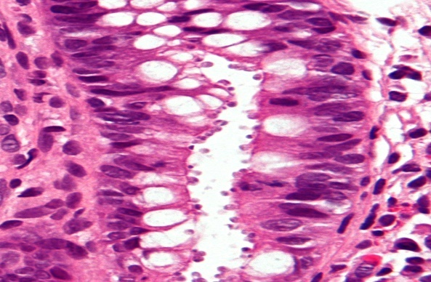

**Fig. (12)**: *Cryptosporidium* in intestinal biopsy stained with H&E stain. The *Cryptosporidium* oocysts are the small, rounded bodies on the surface of the epithelium. Quated from [www.atlas-protozoa.com](http://www.google.com.eg/url?sa=i&rct=j&q=&esrc=s&source=images&cd=&docid=LlP0v3aAXTDwXM&tbnid=efIjOzFvLjxEmM:&ved=0CAQQjB0&url=http%3A%2F%2Fwww.atlas-protozoa.com%2Fgallery.php%3FSOT_CAP%3DCRIPTO&ei=X5p2U9TXJInHOeWEgJAM&bvm=bv.66917471,d.ZWU&psig=AFQjCNH5vEhn84-jPWULiPyLlFha-eAzFg&ust=1400367868828680).

**(4) Immunological diagnosis:**

**A- In stool:**

1. **Coagglutination test:**

The Co-agglutination test is a simple and rapid slide agglutination test that can be performed in a routine laboratory without any need for trained personnel, expensive reagents, or equipment. The test is based on the immunological reaction between specific parasite antibodies and parasite antigen ***(Weber et al., 1991)***.

This test is recommended as a tool for detecting *Cryptosporidium* antigen in a large scale of epidemiological surveys ***(Khalifa et al., 2000).***

**2- Monoclonal antibody immunofluorescence assay (IFA):**

Immunological-based methods appeared with the development of polyclonal and monoclonal antibodies, these antibodies may be combined with several molecules for instance, fluorescent fluorochromes to develop fluorescent antibody tests. The most routinely used technique is the direct immunofluorescence assay with monoclonal antibodies because it is a sensitive and specific technique and fast to perform but it requires an epifluorescent microscope. *Cryptosporidium* oocysts are round or slightly ovoid objects that exhibit a bright apple-green fluorescence under the filter set ***(Fayer et al., 2000)****.*

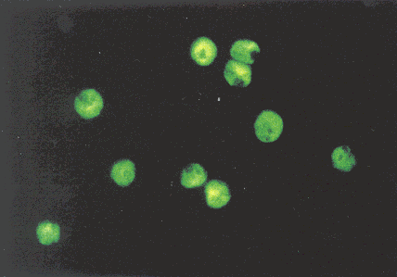

**Fig. (13):** *Cryptosporidium* oocysts in a stool smear with monoclonal antibodies conjugated to fluorescein. The *Cryptosporidium* oocysts appear with a peripheral green fluorescence. Quated from [www. dpdx.cdc.gov](http://www.DpDx.cdc.gov).

**3- Solid-phase qualitative immunochromatographic assay:**

This assay can detect *Cryptosporidium* in aqueous extracts of human faecal specimens. It is performed in approximately 10 minutes on formalin-fixed stool specimens using specific antibodies. The antigens are isolated and immobilized on the substrate and the assay results are read visually which seen as pink or grey lines (regardless of intensity of infection) on the membrane in the resulting window ***(Abaza, 2008)***.

Although the reagent costs may be more than those of the routine ova and parasite methods, the labor costs are considerably less, and it has sensitivity of 93.5% to 97.2% and specificity of 100% (***Abaza,2008)****.*

***Zaglool et al. (2013)*** performed a study on a total of 85 stool samples from suspected patients with cryptosporidiosis to compare immunochromatographic assay rapid test with MZN stain for diagnosis of cryptosporidiosis and found that out of a total of 85 specimens, immunochromatographic assay detected 7 *Cryptosporidium* positive cases (8.2%) but MZN detected 6 positive cases (7.1%).

**4- Enzyme linked immunosorbent assay (ELISA):**

Generally, the tests used for detection of faecal antigens as ELISA. They offer simplicity and they save time in the laboratory and is found to be less-time consuming, easier to perform, offers a less subjective method than microscopy and has high sensitivity and specificity even in presence of low quantities of antigen ***(Lequin, 2005)***. False positives however are almost always reported in these assays possibly due to the presence of cross-reacting faecal antigens seems likely and the interpretation of these findings is difficult***(Lequin, 2005)***.

Enzyme-linked immunosorbent assays (ELISAs) have been reported to be up to 10 times more sensitive than acid-fast staining making the ELISA method currently the “gold standard” for antigen detection in infected stool samples ***(Chappell and Okhuysen***, ***2002)***.

Although its cost is higher than that of M.Z.N stain this allows diagnosis even when the integrity of the parasite is compromised and it is useful for ruling out cryptosporidiosis in immunocompromised individuals especially when there are indicative clinical signs with inconclusive microscopic diagnosis (***Marques et al., 2005)****.*

ELISA is a highly sensitive and specific technique and is useful for screening of a large number of specimens in a short time and may eliminate some of the skills in performing staining procedures and recognizing morphology of small *Cryptosporidium* oocyst ***(kaushik et al., 2008)***.

Antigen assays have an advantage of not requiring a skilled microscopist and their specificity has been reported to be high. However, variable sensitivities and specificities have been reported using different kits. The commercially available coproantigen detection ELISA formats use monoclonal antibodies which recognize different sets of surface epitopes and mAbs used in the ELISA kits may not react or react weakly with antigens of different*Cryptosporidium* species. ***(Khurana et al.,2012)****.*

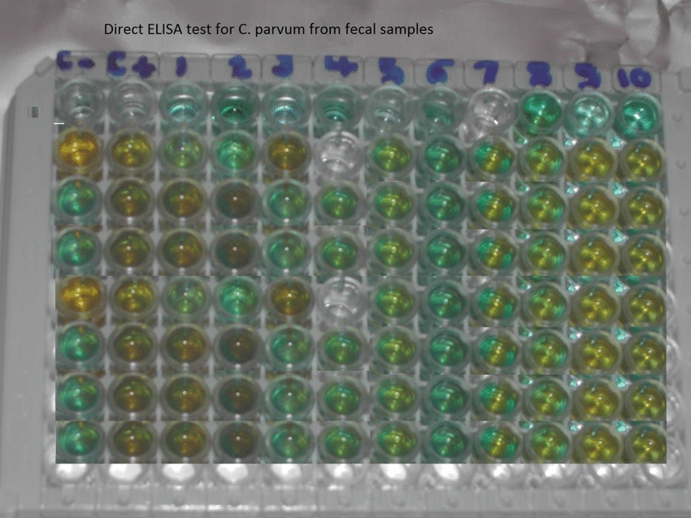

**Fig. (14):** Direct ELISA test for the qualitative determination of *Cryptosporidium parvum* copro antigen in stool ***(Abdul aziz, 2014).***

**5- Flow cytometry:**

Flow cytometry methods for quantitation of *Cryptosporidium* oocysts in stool specimens have been developed as an alternative approach. Studies indicate that the results are approximately 10 times more sensitive than those of conventional immunofluorescence assay however, this approach is somewhat impractical for most clinical laboratories ***(Garcia, 2007)****.*

In addition to the utilization of flow cytometry for detection and enumeration of oocyst recent developments have pointed to this approach being modified to the staining and enumeration of the sporozoites from *in vitro* cultures, allowing the investigation of infection dynamics and quantification of host cell invasion rates ***(Jex et al., 2008)****.*

**B- In serum:**

Infection with *Cryptosporidium* in human and animals elicits development of characteristic serum and mucosal IgG and IgM and IgA antibody responses against parasitic antigens detectable by ELISA, immunofluorescence assay or western blot analysis, although detection of specific serum antibodies should not be necessarily regarded as indicative of an active infection some antigens identified by immunoblot analysis are recognized by IgG, IgM and IgA antibodies of human and are considered as excellent markers of infection ***( Lee et al., 2009)****.*

However serologic testing has little role in clinical diagnosis, but it is used in outbreak situations and for epidemiological studies while oocyst can only be detected in the acute phase of the disease ***(Garcia, 2007)***. Serum antibodies to *Cryptosporidium* spp*.* that result from infection are detectable over many months thus the extent of an outbreak could be estimated in a retrospective analysis using serological methods ***(Brockmann et al., 2008)***.

As the different serological assays have different sensitivities, absolute prevalence rates from different studies cannot be compared directly. The introduction of a serological standard for cryptosporidiosis would facilitate comparison of studies from different laboratories ***(Brockmann et al., 2008)****.*

The methodologies used in the detection of *Cryptosporidium specific* antibodies vary widely, which complicates comparison of results. The use of the recombinant *Cryptosporidium* protein 41antigen in a standardized serodiagnostic assay could provide a reliable and cost-effective method for assessing human exposure to *Cryptosporidium* in developing countries ***(Kjos et al., 2005)****.*

A number of newer serology-based assays that are highly specific and sensitive have emerged, such as the Falcon assay screening test ELISA (FAST-ELISA), rapid antigen detection system (RDTS) and luciferase immunoprecipitation system (LIPS) ***(Burbelo et al.,2005)****.*

Alternatively, oocyst antigen capture methods such as enzyme immune assays (EIAs) or immunochromatographic lateral flow (ICLF) assays may be used and positive reactions must be confirmed by using a suitable confirmatory test ***(Chalmers et al., 2010)****.*

**Polyacrylamide Gel Electrophoresis (Western Blot):**

Polyacrylamide gel electrophoresis was performed followed by enzyme- linked immunotransfere blot technique (Western Blot) to determine which cryptosporidial antigen evokes an antibody response in human ***(Ungar & Nash, 1986)****.*

The sera were collected from 40 patients with cryptosporidiosis (24 AIDS and 16 non-AIDS) and 63 individuals with positive ELISA for IgA or IgM antibody, out of infected individuals 93% (37/40) and 92% (58/63) of ELISA positive individuals had antibodies recognizing the band 23-Kilodalton (23- KDa) of *Cryptosporidium* antigen. The sera of 22 out of 24 AIDS patients were positive for IgG by ELISA recognized the 23-KDa band as well enzyme-linked immunotransfere blot technique was more complicated and less sensitive than ELISA testing ***(Ungar & Nash, 1986)****.*

An immunoglobulin monoclonal antibody (Mab5c3) was developed against 15-KDa surface glycoprotein (gp15) of *Cryptosporidium* sporozoites ***(Tilley et al., 1991)****.* Immunoblot for detecting the 17 and 27KDa sporozoite antigens which associated with recent infection were done and they may be useful for epidemiological investigations ***(Kaplan et al., 2002)****.*

**Oxidative stress**

Oxidative stress is defined as an alteration in the steady-state balance between oxidant and antioxidant agents in the cells. It is caused by an over production of reactive oxygen species (ROS). A balance between ROS and primary antioxidant defenses which mainly include antioxidant scavenging enzymes like superoxide dismutase (SOD), catalase (CAT) and glutathione peroxidise (GSH) is needed in preventing damage by oxidative stress ***(Bosch et al., 2015).***

There are few reports in literature documenting the role of ROS in the pathogenesis of C. parvum infection.

In a previous study, showing that experimental infection with C. parvum in immunocompromised Swiss albino mice causes decrease in GSH and SOD at the peak of infection. These findings clearly implicate production of ROS in pathogenesis of experimental C. parvum infection in mice ***(Bhagat et al., 2017).***

Previous studies suggested that the antioxidant enzymes might have a protective effect in case of C. parvum infection against ROS that occurs via inflammation or phagocytosis by macrophages ***(Andreyev et al., 2005).***

Based on a study by ***Abd El-Hamed et al., (2021)***, it can be concluded that a combination of fig and olive leaf methanolic extracts is a promising therapeutic agent against *Cryptosporidium*, diminishing the oocysts shedding and significantly increasing in levels of GSH, SOD and CAT toward the normal levels.

**III- Molecular Diagnosis:**

Molecular-based approaches such as loop-mediated isothermal amplification (LAMP) real-time polymerase chain reaction and luminex have shown a high potential for use in parasite diagnosis with increased specificity and sensitivity ***(Tait et al., 2009)****.*

Detection of cryptosporidiosis using PCR-based methods is more sensitive than by conventional microscopical and serological methods for detecting oocysts in faeces. Molecular methods can also identify the species/genotypes and subtypes of *Cryptosporidium,* important for determining the epidemiology of *Cryptosporidium* and predicting transmission routes ***(Caccio et al., 2005)****.*

Detection of *Cryptosporidium* DNA by PCR is used in some diagnostic laboratories ***(Bouzid et al., 2008)****.* The diagnostic sensitivities of routine tests have been compared, demonstrating the superior performance of PCR over comparable performances of ELISA and fluorescent stains, which in turn were better than acid-fast staining and ICLF assays ***(Chalmers et al., 2011)****.*

For some patients, especially those who are severely immunocompromised, alternative samples may be more appropriate, and endogenous life cycle stages may be sought by the histological staining of gastrointestinal or other biopsy samples. PCR-based methods for the detection of *Cryptosporidium* DNA may also be applied following tissue digestion and to sample types as bile and bronchoalveolar lavage fluid specimens, as indicated by the patient's symptoms ***(Davies and Chalmers, 2009).***

Polymerase chain reaction detection from stool samples depends on effective DNA extraction, which is hampered by the robust oocysts, which require additional disruption steps such as chemical treatment, bead beating, freeze-thaw cycles, or boiling, to access the sporozoite DNA ***(Chalmers et al., 2011)****.*

PCR were applied in routine diagnostic settings is part of multiplex gastrointestinal parasite panels and can identify the *Cryptosporidium* genus but not the species. Species identification by PCR-restriction fragment length polymorphism (RFLP), PCR sequencing, or real-time PCR assays is usually performed as a reference test in specialist laboratories and is applied more comprehensively in some countries than in others ***(Xiao, 2010)***.

RFLP is used for species differentiation, restriction enzymes are used to digest amplicons in fragments of varying size, depending on the species, that cause the products to migrate in different distances on the gel ***(Ghaffari et al., 2014)****.* Recombinase amplification polymerase (RPA) is a single tube, isothermal alternative to the [polymerase chain reaction](http://en.wikipedia.org/wiki/Polymerase_Chain_Reaction) (PCR). By adding a [reverse transcriptase](http://en.wikipedia.org/wiki/Reverse_transcriptase) enzyme to RPA reaction it can detect [RNA](http://en.wikipedia.org/wiki/RNA) as well as [DNA](http://en.wikipedia.org/wiki/DNA), without the need for a separate step to produce [cDNA](http://en.wikipedia.org/wiki/CDNA). Because it is [isothermal](http://en.wikipedia.org/wiki/Isothermal), RPA reactions need much simpler equipment than PCR, which needs a [thermal cycler](http://en.wikipedia.org/wiki/Thermal_cycler) ***(Zachary et al., 2014)****.*

**A (-V**e**) B (+V**e **)**

**Image: Strips developed at Rice University to look for the diarrheal disease cryptosporidiosis show the difference between positive and negative test results. Control stripes on the right show both tests are valid, while the presence of a second stripe near the center of the top strip shows that parasites are present in the patient\'s stool (Photo courtesy of Rice University).**

**Fig. (15):** Strips developed at Rice University to look for the diarrheal disease cryptosporidiosis show the difference between positive and negative test results. Control stripes on the right show both tests are valid, while the presence of a second stripe near the center of the top strip shows that parasites are present in the patient's stool (Photo courtesy of Rice University) ***(Zachary et al., 2014)****.*

**IV-Animal Inoculation:**

Definitive confirmation of the presence of *Cryptosporidium* spp. oocysts in faecal samples could be obtained by oral inoculation in suckling pathogen free mice with fresh material of faeces that were sieved and centrifuged for 5 minutes at 2000 rpm ***(Sherwood et al., 1982)****.*

**V- Radiological diagnosis:**

Radiology of cryptosporidiosis cases is non-specific. In immuodeficient patients that show clinical manifestation of small bowel affection, radiological findings that suggestive of cryptosporidial infection include irregularity, hypersecretion with segmentation and flocculation and some degree of dilatation of the small intestine this may be associated with narrowing and rigidity of gastric antrum ***(Berk et al., 1984)***.

***White (2006)*** reported that dilated or irregular intrahepatic and extrahepatic bile ducts along with a thickened gall bladder when using abdominal ultrasound indicate biliary involvement with *Cryptosporidium* infection.

**TREATMENT**

**# Medical treatment**

## **1-Symptomatic Therapy**

Optimal therapy for cryptosporidiosis includes attention to fluids and electrolytes, antimotility agents, nutritional support, and reversal of immunosuppression ***(White et al., 2015)****.*[Symptomatic treatment](https://en.wikipedia.org/wiki/Symptomatic_treatment) primarily involves [fluid rehydration](https://en.wikipedia.org/wiki/Management_of_dehydration), electrolyte replacement (sodium, potassium, bicarbonate, and glucose), and [antimotility agents](https://en.wikipedia.org/wiki/Antimotility_agent) (e.g., [loperamide](https://en.wikipedia.org/wiki/Loperamide)). Supplemental zinc may improve symptoms particularly in recurrent or persistent infections or in others at risk for [zinc deficiency](https://en.wikipedia.org/wiki/Zinc_deficiency) ***(Cabada, 2016)****.*

## **A-Fluid and Electrolyte Replacement**

Replacement of fluids and electrolytes is the critically important first step in the management of cryptosporidiosis particularly in patients with large diarrheal losses. Fluids should include sodium, potassium, bicarbonate, and glucose. Oral rehydration is the preferred mode, but severely ill patients may require parenteral fluids ***(Miguel et al., 2016)****.*

## **B-**[**Antimotility Agents**](https://en.wikipedia.org/wiki/Antimotility_agent)

Treatment with antimotility agents as Loperamide or diphenoxylate-atropine may help in some cases. More potent opiates, including anhydrous morphine (Paregoric) may work in some cases that fail to respond to milder agents. Octreotide, a somatostatin analogue and substance P antagonist suppresses diarrhea in chronic cryptosporidiosis ***(Miguel et al., 2016)****.*

**2-Antiparasitic Therapy**

In the last years, up to 100 active components have been tested for their suitability as an anti-cryptosporidial chemotherapeutic ***(Stockdale et al., 2008)****.* Although several pharmacological compounds *in vitro* studies showed an anti-cryptosporidial activity considerably fewer demonstrated a significant potential in animal experiments and many compounds with initially positive results ultimately were ineffective or only partially effective ***(Shahiduzzaman and Daugschies, 2012)****.*

Although, nitazoxanide was an important innovative drug treatment for cryptosporidiosis in children, it has a limited efficacy in compromised or malnourished patients. This raises an important question about the proper management for these patients ***(sparks et al,*** [***2015***](https://link.springer.com/article/10.1007/s12639-020-01241-5#ref-CR18)***)***.

There are few available drugs against cryptosporidiosis like Azithromycin, Paromomycin, Roxithromycin and antiretroviral drugs. Unfortunately, these drugs are not effective to kill the infectious oocyst with probable side effects in addition to restricted availability in developing countries ***(Gargala,*** [***2008***](https://link.springer.com/article/10.1007/s12639-020-01241-5#ref-CR12)***)***.

Progress in developing anti cryptosporidial drugs has been slow due to the limitations of in vitro culture for *Cryptosporidium*, an inability to genetically manipulate the organism and the unique metabolic features in this parasite, which has a highly streamlined metabolism and is unable to synthesize nutrients de novo ***(Guo et al., 2014).***

**A-Chemical treatment**

**1-Nitazoxanide**

Nitazoxanide (NTZ) is a nitro thiazolyl-salicylamide derivative. Nitazoxanide exerts its antiprotozoal activity by interfering with the [pyruvate](https://pubchem.ncbi.nlm.nih.gov/compound/pyruvate) ferredoxin/flavodoxin oxidoreductase dependent electron transfer reaction, which is essential to anaerobic energy metabolism. PFOR enzyme reduces nitazoxanide, thereby impairing energy metabolism ***(Bobak, 2006)****.*

Nitazoxanide has shown the most promise against *Cryptosporidium* ***(Mor and Tzipori, 2008)****.* It is used in many areas of the world because it appears to be well tolerated, it has a relatively low incidence of adverse effects, and it displays no significant known drug-to- drug interactions ***(Bobak, 2006)****.* However, it is not effective against cryptosporidiosis in immunocompromised persons. A meta-analysis of randomized, placebo-controlled trial of NTZ (of which there are only 2) among immunocompromised patients concluded that NTZ was no more effective than placebo in resolving diarrhea and achieving parasitological clearance in HIV-positive persons ***(Abubakar et al., 2007)****.*

The drug was originally developed as a veterinary anthelminthic. Subsequent studies describe a broad antibiotic spectrum, including helminths, viruses and protozoan parasites ***(Rossignol, 2006).***

Nitazoxanide seemed to be more effective in light infections and less effective in moderate-to-heavy infections *(****Doumbo et al., 1997).***

In a trial in adult HIV patients with cryptosporidiosis, Nitazoxanide dosed at 500 mg to 1 g twice daily for 2 weeks was superior to placebo among those with CD4+ T-cell counts greater than 50/mm3 but was not better in those with lower CD4+ T-cell counts (***Rossignol et al., 1998).***

**2-Paromomycin**

Paromomycin is an oral non absorbable aminoglycoside originally approved in the 1960s for treatment of amebiasis, it inhibits protein synthesis by binding to 16S ribosomal RNA **(*Hashmey et al., 1997).*** Paromomycin has been used for the treatment of cryptosporidiosis in adults and children with various levels of success ***(Stockdale et al., 2008****)*.

A small prospective double-blind trial in advanced AIDS patients compared paromomycin (25–35 mg/kg/day for 2 weeks) with placebo. Treatment with paromomycin significantly decreased parasite shedding (by quantitative assays of stool), improved diarrheal symptoms. However, only one out of ten patients completely cleared the infection and several patients developed co infections with *Mycobacterium* species ***(White et al., 1994).***

**3-Azithromycin**

Azithromycin is a macrolide antibiotic used to treat respiratory tract infections and bacterial gastrointestinal infections ***(Trad et al., 2003).*** Macrolides stop growth by inhibiting protein synthesis and translation ***(Dinos, 2017)***. Several case reports described successful treatment of cryptosporidiosis with azithromycin ***(Kadappu et al., 2002).*** In a pilot study in egyptian school children, treatment with 500 mg/day for 3 weeks resulted in a 91% cure rate and a 99% reduction in oocysts in stool samples ***(Allam and Shehab, 2002).***

A large multicenter study, reported as an abstract, noted no difference in oocyst shedding, stool frequency and weight loss between patients who were treated with azithromycin (900 mg orally daily) or placebo control ***(Stockdale et al., 2008).*** A pilot trial did not demonstrate changes in stool frequency or oocyst shedding after administration of intravenous azithromycin ***(Stockdale et al., 2008).***

**4-Rifaximin**

Rifaximin is a poorly absorbed rifampicin antibiotic that is FDA approved for treatment and commonly used for prevention of traveler’s diarrhea ***(Amenta et al., 1999).*** Uncontrolled studies have described responses in AIDS patients with cryptosporidiosis ***(Gathe et al., 2008).***

The related compound rifabutin is active in vitro against *Cryptosporidium,* and use of rifabutin prophylaxis for *Mycobacterium* *avium* complex has been associated with decreased rates of cryptosporidiosis ***(Fichtenbaum et al., 2000).***

**5-Benzoxaboroles**

Are potent inhibitors of *C. Parvum* growth in an in vitro model and calf model of cryptosporidiosis ***(Lunde et al., 2019).***

**6-Bicyclic azetidines**

Are also potent inhibitors of *C. parvum* growth in vitro ***(Jumani et al., 2019)*.** Previous studies in *P. falciparum* have also highlighted the potency of bicyclic azetidines that inhibit parasite phenylalanine tRNA synthetases (PheRS) ***(Kato et al., 2016),*** suggesting that these may also have broad-spectrum activity against other apicomplexans.

The majority of studies that have identified new inhibitors have utilized microliter plate-based growth assays that do not rely on knowledge of specific targets. To better understand their mode of action, it would be beneficial to develop assays that identify when compounds act across the life cycle and to define the minimum concentration and time required to achieve complete killing in vitro ***(Leroy et al., 2014).***

**Atorvastatin (ATV)**

**Structure**

Atorvastatin calcium is [R-(R*, R*)]-2-(4-fluorophenyl)-ß, δ-dihydroxy-5- (1-methylethyl)-3-phenyl-4-[(phenylamino) carbonyl]-1H-pyrrole-1-heptanoic acid, calcium salt (2:1) trihydrate. The empirical formula of atorvastatin calcium is (C33H34 FN2O5)2Ca•3H2O and its molecular weight is 1209.42. Atorvastatin calcium is a white to off-white crystalline powder that is insoluble in aqueous solutions of pH 4 and below. Atorvastatin calcium is very slightly soluble in distilled water, pH 7.4 phosphate buffer, and acetonitrile, slightly soluble in ethanol, and freely soluble in methanol. ***(Moghadasian, 1999).***

Atorvastatin was first synthesized in 1985 by Dr. Bruce Roth and approved by the FDA in 1996. ***(Corey et al.,2007).***

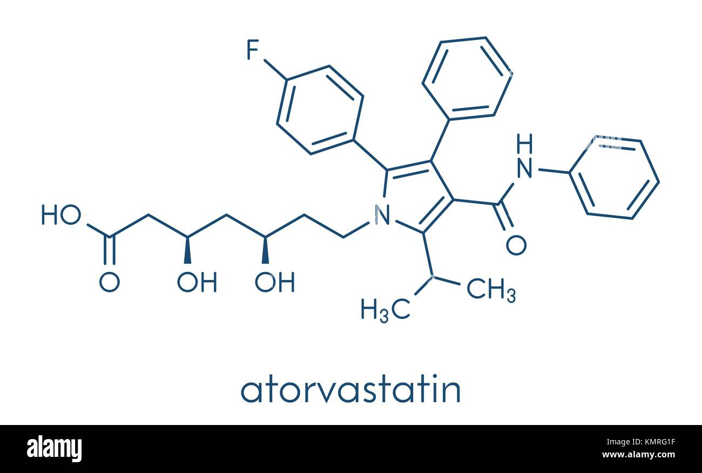 **Fig.(16):** Structure formula of atorvastatin.  <https://pubchem.ncbi.nlm.nih.gov/compound/Atorvastatin>.

**Mechanism of action**

Atorvastatin competitively inhibits 3-hydroxy-3-methylglutaryl-coenzyme A (HMG-CoA) reductase. By preventing the conversion of HMG-CoA to mevalonate, statin medications decrease cholesterol production in the liver. Atorvastatin also increases the number of LDL receptors on the surface of hepatic cells. ***(Dagli-Hernandez et al., 2022).***

In patients with homozygous or heterozygous familial hypercholesterolemia, mixed dyslipidemia, isolated hypertriglyceridemia, or nonfamilial hypercholesterolemia, atorvastatin has been shown to reduce total cholesterol (TC), low-density lipoprotein cholesterol (LDL-C), apolipoprotein B (apo B), very-low-density lipoprotein (VLDL-C) and triglycerides (TGs) while increasing high-density lipoprotein cholesterol (HDL-C) ***(Qiu et al., 2017).***

*In vitro* and *in vivo* animal studies also demonstrate that atorvastatin exerts vasculoprotective effects independent of its lipid-lowering properties, also known as the pleiotropic effects of statins. These effects include improvement in endothelial function, enhanced stability of atherosclerotic plaques, reduced oxidative stress and inflammation, and inhibition of the thrombogenic response***. (Liao and Laufs ,2005).***

**Indications**

In combination with dietary modifications, atorvastatin is FDA approved to prevent cardiovascular events in patients with cardiac risk factors and also patients with abnormal lipid profiles ***(Raddino et al., 2010).***

**Adverse effects of atorvastatin**

Common adverse effects for patients taking atorvastatin include arthralgia, dyspepsia, diarrhea, nausea, nasopharyngitis, insomnia, urinary tract infection, and pain in the extremities. Myopathies have occurred in patients taking atorvastatin, including muscle aches, muscle tenderness, or muscle weakness, with elevated creatine phosphokinase greater than ten times the upper limit of normal. Rhabdomyolysis has been reported in patients using atorvastatin ***(Nemati et al., 2021).***

**Contraindications of atorvastatin**

Atorvastatin contraindications include patients with hypersensitivity to any of its components. While atorvastatin contraindications also include patients with active liver disease, the benefits of lipid-lowering therapy in chronic liver diseases, such as non-alcoholic fatty liver disease and hepatitis, likely outweigh the possible risks ***(Tandra and Vuppalanchi, 2009).*** Atorvastatin is contraindicated during pregnancy or in female patients who may become pregnant. All female patients of childbearing age should receive counseling on the potential risks to a fetus should they become pregnant while on atorvastatin. This risk is most pronounced in the first trimester, so current guidelines recommend ceasing statin therapy for at least three months prior to becoming pregnant ***(Zarek and Koren, 2014).***

**Pharmacokinetics of atorvastatin:**

**Absorption**

Atorvastatin is rapidly absorbed after oral administration with a peak plasma concentration at 1 to 2 hours. The bioavailability is low at 14% due to extensive first-pass metabolism ***(******Goldstein and Brown, 1990).***

**Distribution**

Atorvastatin is highly plasma protein bound (over 98%) and has a volume of distribution of about 380 liters (***Goldstein and Brown, 1990).***

**Metabolism**

Atorvastatin is metabolized by cytochrome P450 3A4 (CYP3A4) to active ortho- and para-hydroxylated metabolites ***(Moghadasian, 1999).***

**Excretion**

Atorvastatin and its metabolites get eliminated in bile. Atorvastatin is not known to go through enterohepatic recirculation. The half-life of atorvastatin is about 14 hours, while its active metabolites have a half-life of about 20 to 30 hours ***(Moghadasian, 1999).***

**Statins in parasitic diseases**

Evidence supports the idea that statins play an anti-parasitic role, partly owing to their ability to reduce cholesterol, increase phagocytosis and produce anti-parasitic molecules. Statins also drive cyclooxygenase 2 (COX2; also known as PTGS2) induction and the generation of lipoxins that downregulate inflammation ***(Karvaly et al., 2021).*** Intracellular parasites rely on cholesterol to anchor onto the host cell membrane for subsequent internalization. For instance, the simultaneous inhibition of both endogenous cholesterol by mevastatin and exogenous cholesterol by lipid-deficient serum decreased the replication and growth of *Toxoplasma gondii* parasites in parasitophorous vacuoles of fibroblasts ***(Coppens et al., 2000).***

This highlights the importance of LDL receptor-mediated acquisition of cholesterol during pathogenesis. Sterol inhibition was also shown to decrease the intracellular growth of *Leishmania donovani* in human macrophages ***(Dinesh et al., 2015).***

During *Leishmania amazonensis* infection, statins increased phagocytosis and nitric oxide production but limited the production of TNF, a tissue-damaging cytokine, in peritoneal macrophages. This macrophage response was associated with an increased survival and decreased footpad swelling in pravastatin treated BALB/c mice ***(Kückelhaus et al., 2013).***

Evidence already suggests a promising outcome for cerebral malaria. Statins administered together with the anti-malarial drugs mefloquine or dihydroartemisinin reduced the mortality of mice infected with *Plasmodium berghei*. This has been associated with decreased neuronal apoptosis ***(Souraud et al., 2012)*** and lower production of tissue-damaging cytokines and chemokines (such as IL-13, CCL4, CCL11, CXC-chemokine ligand 2 (CXCL2) and CXCL5) ***(Dormoi et al., 2013).***

Moreover, in a study using hypercholesterolemic mice, statins administered with the anti-malarial drug artesunate enhanced protection against schistosomiasis. This was achieved by targeting the structural organization of the worms, thereby rendering them susceptible to artesunate ***(Alencar et al., 2016).***

Recently, in an experimental model of cryptosporidiosis, atorvastatin decreased the severity of *Cryptosporidium* spp. Infection in mice immunosuppressed with dexamethasone. Moreover, this protective effect was enhanced when atorvastatin was administered with standard nitazoxanide therapy ***(Taha et al., 2017).***

***Artz et al. (2008)*** reported that *Cryptosporidium spp.* genome has an entree to isoprenoid precursors, by salvaging isoprenoids derived from isopentenyl-5- pyrophosphate (IPP) or other short to-medium-chain isoprenoids from the host as it has three prenyl synthases. A cell-based high-throughput screening (HTS) for anti-cryptosporidial agents; screening the NIH Clinical Collections libraries reported that statins were identified as a hopeful principal candidate with effective capability in inhibiting growth of *Cryptosporidium spp.*

Atorvastatin and high dose nitazoxanide were used as prophylactic regimens to ameliorate the immune status and severity of cryptosporidiosis on immunosuppressed or lower heavy oocysts shedding. Atorvastatin gave progressive decline in oocyst excretion after treatment with subsequent therapeutic dose that was more aggravated by synergistic combined with high prophylaxis nitazoxanide dose ***(AL-Ghandour, et al., 2020).***

**B-Herbal Treatment**

Twenty-two different plant extracts were used against *Cryptosporidium, Giardia lamblia* and *Entamoeba histolytica.*

Five plants types including Allium, Chenopodiumbotrys, Carumcopticum, F.asafoetida and Artemisia annua were able to completely inhibit the tested parasites, while Thymus vulgaris and A. paradoxum showed the lowest inhibitory effect (7%) (***Soosaraei et al., 2020).***

Garlic, Ginger and Mirazid plant extracts proved to have a direct and powerful impact on *C. parvum* and minimized its pathology and complications as compared to metronidazole ***(Nour et al., 2016).***

**# Surgical treatment:**

Biliary involvement in case of biliary cryptosporidiosis, which may develop in severely immunocompromised individuals, drugs other than those used for immune reconstitution have not been demonstrated to be effective. Symptomatic patients may experience pain relief after surgical or endoscopic measures. Cholecystectomy is the main therapy for a calculus cholecystitis ***(Florescu and Sandkovsky, 2016).***

Endoscopic retrograde cholangio pancreatoscopy with sphincterotomy and/or placement of stent to allow drainage and decompression of the biliary system is critical for sclerosing cholangitis ***(Uppal and Wang, 2015).***

**Prevention and control**

About 56% of *Cryptosporidium*-linked outbreaks in the last decade appear to be correlated to waterborne diseases and worldwide environmental. Veterinary surveillance data revealed the presence of *Cryptosporidium* spp. in entire wastewater, surface water and water-treatment systems ***(Putignani and***

***Menichella, 2010)****.*

Since there is no vaccine commercially available to prevent *Cryptosporidium* infection. These parasites have certain characteristics that make them highly contagious (i.e., survival in the environment for a long time and resistance to chlorine-based disinfectants), The only way to avoid the spreading of the parasite to other people is the introduction of preventive measures to control the transmission of the germs that are shed in feces ***(Thomson et al., 2017).***

Many chemotherapeutic studies were conducted to fix this disease, but no effective therapy was recognized. However, some efficient methods that can control this disease are by using appropriate tools for diagnosis, sanitation and hygiene of premises. Proper preventive measures can suppress the occurrence of cryptosporidiosis ***(Amer et al., 2010).***

Secondary transmission is worthy of further investigation, and influencing factors such as age, comorbidity and infectivity potential of specific subtypes need to be considered. Personal hygiene is regarded as a key intervention ***(Johansen et al., 2015).***

Wearing gloves and hand washing after handling diapers can prevent person-to-person spread in daycare centers and hospitals. Endoscopes and similar instruments should be disinfected between uses ***(Miguel et al., 2016)****.*

Current water purification standards do not uniformly remove viable oocysts. Filtration is particularly important when surface contamination may occur in water sources such as during spring runoff, or in households using well water. If personal use water filters are utilized, they should be capable of removing particles 1 µm in diameter ***(Kaplan et al., 2002).***

HIV-infected persons who travel in developing countries should meticulously avoid drinking tap water and contaminated water resources ***(Johansen et al., 2015).***

At-risk persons should avoid contact with obvious sources of *Cryptosporidium* oocysts, such as people with diarrhea (especially regarding sexual practices that involve oral exposure to feces), farm animals (particularly cattle), and domestic pets that are either very young (<6 months), have diarrhea, or have been stray ***(Rossle and Latif, 2013).***

**Nanotechnology**

Nanotechnology refers to the design and use of technologies at the 1- to 100-nm scale. The field of nanomedicine refers to applying nanotechnology to the realm of medicine for improving health ***(Kim et al., 2010)****.*

The field of nanotechnology has been a significant research focus in the last thirty years. This emphasis is due to the unique optical, electrical, magnetic, chemical and biological properties of materials approximately ten thousand times smaller than the diameter of a hair strand ***(Sindhwani and Chan ,2021).***

Benefits from nanoscience and nanotechnology to medicine will take time to become evident; however, other benefits will come immediately. The tools of research and medical practice will be less expensive and more powerful. The research and development of new devices as well as the diagnostics will become, more effective, enabling faster response and the ability to treat new diseases ***(Solano et al., 2015).***

**The physicochemical properties of nanomaterials for medicine**

One of the common ways of thinking about nanomaterials is by dividing them into organic and inorganic materials. Each of these can be then designed with specific chemical, physical and surface properties that subsequently yield desired biological properties and function***(Sindhwani and Chan ,2021).***

Organic nanomaterials can be synthetic or biologically derived and synthesized from polymers, proteins, nucleic acids, carbohydrates and lipids. Organic nanomaterials are commonly biocompatible and have functional diversity. They are typically nontoxic and have low immunological responses since the chemical composition mostly contains carbon, nitrogen and oxygen ***(Mitragotri and Stayton, 2014).***

  These organic nanomaterials are often programmed through chemical or physical properties to bind specific cells and carry medical agents. The FDA-approved anticancer liposome nanoparticle Doxil is an excellent example of a useful organic nanoparticle. Doxil consists of phospholipids, polymers and the active drug doxorubicin ***(Barenholz, 2012).***

Inorganic nanomaterials are also under development for medical applications. A unique feature of these nanomaterials is the tunable properties. The researcher can alter the electrical, optical and magnetic properties by changing the nanoparticle’s physicochemical design. These materials include metals such as gold, copper, zinc and aluminium ***(Yang et al., 2019).***

Physical properties determine the applications of inorganic material. For example, diagnostic imaging using computer tomography, magnetic resonance imaging and positron emission tomography can draw on nanoparticle formulations of gadolinium, iron oxide and radioactive copper ***(Nguyen et al., 2017).***

Gold nanoparticles are essential agents in engineering colorimetric diagnostic tests ***(Yang et al., 2019)***. However, the stability, biocompatibility and immunogenicity may limit the use of inorganic nanomaterials ***(Kairdolf et al., 2013).*** These issues can be resolved by either coating or encapsulating them inside polymers, carbohydrates or other organic materials ***(Verougstraete et al., 2018).***

**Nanomedicine therapeutics**

Nanomaterials are typically used as delivery vehicles to transport drugs to the targeted diseased site. In many diseases, there are candidate drugs that perform with high efficacy in vitro. However, in vivo performance is hampered by poor pharmacokinetics and pharmacodynamics ***(Metselaar and Lammers, 2020).***

Small molecule drugs, proteins and nucleic acid face several challenges once injected into the body. They adsorb serum proteins that mark them for immune recognition and subsequent processing. Drugs below the renal filtration cut-off (<6.5 nm) are excreted, endonucleases degrade nucleic acid drugs, and the innate immune system recognizes them as foreign material ***(Land, 2018)***. These drugs also undergo extensive first-pass metabolism in the liver. Here, the liver enzymes metabolize drugs and reduce the number of active drug molecules at the target site. Non diseased organs such as the liver, spleen, skin and other tissues can sequester the drug and reduce their final accumulation at the target organs. Recognition by off-target cells at these sites can yield serious side effects and organ damage that limit their use clinically ***(Carvalho et al., 2014).***

Nanomaterials address these challenges by acting as a delivery vehicle that can protect the active drug *in vivo*. Nanoparticles can incorporate drugs in various forms. They can be either encapsulated inside the nanoparticle, integrated into the material matrix or presented on the surface, depending on their intended cellular interaction ***(Amoabediny et al., 2018).***

Nanoparticles can alter the function and effectiveness of the drug at the target site. The need for this arises from unfavourable pharmacokinetic and pharmacodynamic profiles of small molecular drugs despite being biologically active *in vitro* ***(Land, 2018)***.

Nanoparticles aim to control these parameters by tuning their physicochemical properties. The nanoparticle design affects the drug transport rate to the diseased site and release rates, which affects the exposure of the diseased target to the drug. Additionally, valency, avidity, configuration and presentation of the drug on the nanoparticle surface can influence its interaction with the target. The fine-tuning of the nanoparticle properties can provide specific control over the target specificity and efficacy of drugs ***(Sindhwani and Chan ,2021).***

**Application of Nanomedicine in treatment of parasitic diseases:**

**As sole treatment,** targeting infected macrophages with NPs is a valuable and validated strategy for treatment of visceral leishmaniasis ***(Kunjachan et al., 2012).***

Combined therapy by silver, chitosan, and curcumin NPs gave the highest effect and complete cure in giardiasis in experimentally infected animals ***(Said et al., 2012).***

Silver and chitosan (CS) were evaluated singly or combined for *in vivo* treatment of toxoplasmosis in experimental animals. The combined treatment showed significant decrease in hepatic and splenic parasite burden. Microscopic examination revealed stoppage of movement and deformity in the shape of tachyzoites ***(Gaafar et al., 2014).***

**As a drug delivery system**, quercetin conjugated with gold NPs was established for treatment of visceral leishmaniasis caused by wild-type resistant strains ***(Das et al., 2013).*** On the other hand, CS proved to be a suitable drug delivery mean for several drugs used in visceral leishmaniasis treatment. Doxorubicin displayed significant reduction in *Leishmania* amastigotes (*in vivo*) and promastigotes (*in vitro*), while amphotericin B and rifampicin gave significant results compared with control drugs without CS. Amphotericin B was also encapsulated in Poly (lactic-co-glycolic acid) PLGA NPs and gave significantly effective results in comparison with the drug alone ***(Kumar et al., 2015).***

In cutaneous leishmaniasis, glucantime formulated with liposomes was effective in the topical treatment of leishmanial ulcers caused by *L. major* in mice. It resulted in a significant decrease in lesion size and spleen parasite burden ***(Kalat et al., 2014).***

Isolated fungus from the soil (*Trichoderma harzianum*) conjugated with silver NPs increased the efficacy of triclabendazole in the treatment of fascioliasis ***(Gherbawy et al.,2013).***

In cryptosporidiosis, polyvinyl alcohol conjugated with CS was proven to suppress the attachment of *Cryptosporidium* sporozoites to enterocytes *in vitro* (***Luzardo Álvarez et al., 2012)****.*

Binding of curcumin and choloroquie to chitosan increased chemical stability and enhanced bioavailability when evaluated in the treatment of malaria in infected mice ***(Tripathy et al., 2013).***

Albendazole bound to CS was effective in the treatment of alveolar echinococciosis caused by *E. multilocularis* ***(Abulaihaiti et al., 2015)*** and visceral larva migrans caused by *T. canis (****Barrera et al., 2010)****.*

In the treatment of schistosomiasis *mansoni*, praziquantel (300 mg/kg) encapsulated in liposomes showed a significant reduction in worm burden and stool and intestinal egg counts as well as in the number of hepatic granulomas ***(Frezza et al., 2013).***

**Silver nanoparticles:**

Silver nanoparticles are [nanoparticles](https://en.wikipedia.org/wiki/Nanoparticle) of [silver](https://en.wikipedia.org/wiki/Silver) between 1 nm and 100 nm in size. While many are classified as "silver" due to the enormous ratio of surface to bulk silver atoms, some have a high amount of silver oxide. Nanoparticles can be made in a variety of shapes, depending on the application. Spherical silver nanoparticles are the most prevalent, but diamond, octagonal and thin sheets are also popular **(*Graf et al., 2003*).**

**Synthesis of AgNPs:**

**Synthesis of AgNPs Using Physical, biological and Chemical Methods:**

Generally, the synthesis of nanoparticles has been carried out using three different approaches, including physical, chemical and biological methods.

**In physical methods**, Evaporation-condensation nanoparticles are made in a tube furnace at ambient pressure **(*Kruis et al., 2000*).** AgNPs were synthesised using traditional physical processes such as spark discharge and pyrolysis ***(Tien et al., 2008)***. Physical methods have the advantages of speed, the use of radiation as a reducing agent and the absence of toxic chemicals, but they also have the disadvantages of low yield, high energy consumption, solvent contamination and lack of uniform distribution ***(Elsupikhe et al., 2015).***

**Chemical methods** use water or organic solvents to prepare the silver nanoparticles (***Tao et al., 2006).*** Metal precursors, reducing agents and stabilizing/capping agents are the three key components used in this process. The reduction of silver salts is divided into two stages: nucleation and subsequent growth ***(Mallick et al., 2004).*** In general, silver nanoparticles can be made in one of two ways: "top-down" or "bottom-up." ***(Deepak et al., 2011).*** Mechanical grinding of bulk metals with subsequent stabilisation using colloidal protective agents is known as the "top-down" approach. Chemical reduction, electrochemical techniques, and sono-decomposition are examples of "bottom-up" approaches ***(Mallick et al., 2004).***

**Biological Applications of AgNPs:**

**Antiparasitic effect of silver nanoparticle:**

The antiparasitic activity of silver and copper oxide nanoparticles were tested against two of the most environmentally spread parasites in Egypt (*Entamoeba histolytica* and *Cryptosporidium parvum*). The average sizes of synthesized silver nanoparticles (Ag NPs) and copper oxide nanoparticles (CuO NPs) were 9 & 29 nm respectively and a significant reduction for cysts viability (p < 0.05) was observed for CuO NPs against *E. histolytica* cysts and Ag NPs against *C. parvum* oocysts ***(Saad et al., 2015).***

In the dark, Ag-NPs inhibited the proliferation and metabolic activity of leishmanial promastigotes by 1.5 to threefold, while under ultraviolet (UV) light, they inhibited the proliferation and metabolic activity of promastigotes by 2- to 6.5-fold. The survival of amastigotes in host cells was decreased by Ag-NPs and this impact was stronger in the presence of UV radiation. For the first time, Ag-NPs were shown to have antileishmanialeffects on *L. tropica* parasites, as well as improved antimicrobial activity when exposed to UV light ***(Adil et al., 2011).***

In the case of *Toxoplasma*, treatment with nanoparticles prevented liver damage as measured by enzyme activity inhibition, as well as a significant reduction in hepatic NO levels. Furthermore, nanoparticle therapy considerably reduced hepatic lipid peroxidation (LPO) and NO concentrations, as well as proinflammatory cytokines, while significantly increasing liver homogenate antioxidant enzyme activity **(*Alajmi et al., 2019).***

# In trophoblast cells and villous explants, biogenic silver nanoparticles (AgNp-Bio) can reduce *T. gondii* infection. Because of the activation of inflammatory mediators in the cells, this therapy was able to inhibit *T. gondii* proliferation. After infection, the AgNp-Bio therapy reduced the production of IL-4, IL-6, and IL-8 in villous explants ***(Costa et al., 2021).***

# Fluorescence microscopy and scanning electron microscopy techniques are used to examine the effect of AgNPs on *Salmonella braenderup* oocysts. The findings revealed that morphological changes in the cell structure of *S. braenderup* oocysts were observed at different ratios of AgNPs and microorganisms, as well as at different exposure times during the treatments, indicating a potential treatment method for inhibiting the viability of these microorganism ***(Duque et al., 2020).***

**Antifungal Activity of AgNps**

Fungal infections are more common in immunocompromised patients, and conquering fungi-mediated diseases is a time-consuming procedure due to the limited number of antifungal medications ***(Kim et al., 2008).*** As a result, there is a need to produce biocompatible, non-toxic and acceptable antifungal agents. At this point, AgNPs serve a significant role as anti-fungal agents against a variety of fungal infections. With doses of 1–7 µg/mL, Nano-Ag showed strong anti-fungal action against clinical isolates and strains of Trichophyton mentagrophytes and Candida species. ***Esteban-Tejeda et al. (2009)*** created a biocidal inert matrix incorporating AgNPs with an average size of 20 nm in a soda-lime glass.

**Antiviral Activity of AgNPs**

AgNPs interact with bacteria and viruses differently depending on their size ***(Esteban-Tejeda et al., 2009).*** The antiviral efficacy of nano-Ag integrated into polysulfone ultrafiltration membranes was tested against MS2 bacteriophage, revealing that improved membrane hydrophilicity resulted in considerable antiviral activity ***(Zodrow et al., 2009).*** Poly vinyl pyrrolidone (PVP)-coated AgNPs prevented the transmission of cell-associated human immunodeficiency virus HIV-1 and cell-free HIV-1 isolates ***(Lara et al., 2010*)**. AgNPs have been shown to be effective inhibitors of the human immunodeficiency virus (HIV) and the hepatitis B virus (HBV) ***(Xiang et al., 2011).***

**Antibacterial Activity of AgNPs**

***Sondi and Salopek-Sondi (2004)*** published a seminal paper demonstrating AgNPs' antimicrobial activity against *Escherichia coli*, in which *E. coli* cells treated with AgNPs showed AgNP accumulation in the cell wall and the formation of "pits" in the bacterial cell walls, eventually leading to cell death.

**Anti-Inflammatory Activity of AgNPs**

***Bhol* and *Schechter (2007)*** reported the anti-inflammatory activity of AgNP in rat. Rats treated intra-colonically with 4 mg/kg or orally with 40 mg/kg of nanocrystalline silver showed significantly reduced colonic inflammation. Mice treated with AgNPs showed rapid healing and improved cosmetic appearance, occurring in a dose-dependent manner. AgNPs also shown antibacterial activity, wound inflammation reduction, and regulation of fibrogenic cytokines ***(Tian et al., 2007).***

**Toxicity of silver nanoparticles:**

Despite the widespread usage of silver nanoparticles in a range of commercial products, there has been a significant effort to investigate their impact on human health. The in vitro toxicity of silver nanoparticles to a range of organs, including the lung, liver, skin, brain, and reproductive organs, has been shown in multiple investigations **(*Ahmed et al., 2010).*** The toxicity of silver nanoparticles to human cells appears to be produced by oxidative stress and inflammation, which is induced by the production of reactive oxygen species (ROS), which is promoted by either Ag NPs, Ag ions, or both ***(Gopinath et al., 2010).***  The viability of a mouse peritoneal macrophage cell line (RAW267.7) was reduced by silver nanoparticles in a concentration and time-dependent manner. They also discovered that the intracellular reduced glutathionine (GSH), a ROS scavenger, dropped to 81.4 percent in the silver nanoparticles at 1.6-ppm control group ***(Park et al., 2010).***